



Instructor:

[**Cihan**](https://www.udemy.com/course/oracle-sql-developer-training/)[**O’zhan**](https://www.youtube.com/playlist?list=PLr48dQTh3FFxybyTc0whJOI2hwHNcipym)

Researcher, Developer

Owner:

[**Azamat**](https://t.me/Azamat_Nishonov)[**Nishonov**](https://t.me/sql_portfolio_24)

SQL Developer

Content

Introduction 4

Create Connection 4

Working with Database Object 4

Create Table with SQL 4

Creating Tables Using Table Dialog 5

Copy Table to Table and SQL Dialog 7

Adding a new column to the table 9

Data access 10

Receive Columns 10

Getting rows 11

Oracle Sql Query Builder 12

JOIN’s Understanding 14

ON CLAUSE with the JOIN operation 15

Writing a Query That Joins Multiple Tables 16

Character functions 16

Numeric Functions 17

Date/Time Functions 17

Date Formatting 18

NVL Functions 18

Use of Group Functions 19

Grouped Data Reports 19

Use the HAVING clause 20

Data Processing 20

Add Single Line Data 20

Adding Multi-Line Data 21

Update Data 22

Delete Data 22

Excel to Export 23

Export to DDL 24

Adding components PL/SQL 27

Create DML Trigger 27

Manage Trigger 28

Create Stored Procedure 29

Use of Function 31

SYNONYM 32

VIEW 34

Sequence 35

# Introduction

## Create Connection

Kod yozish stolini ochish uchun:

(baza ustiga o’ng knopka bosilib, *Open SQL Worksheet* bosiladi)

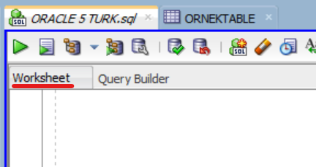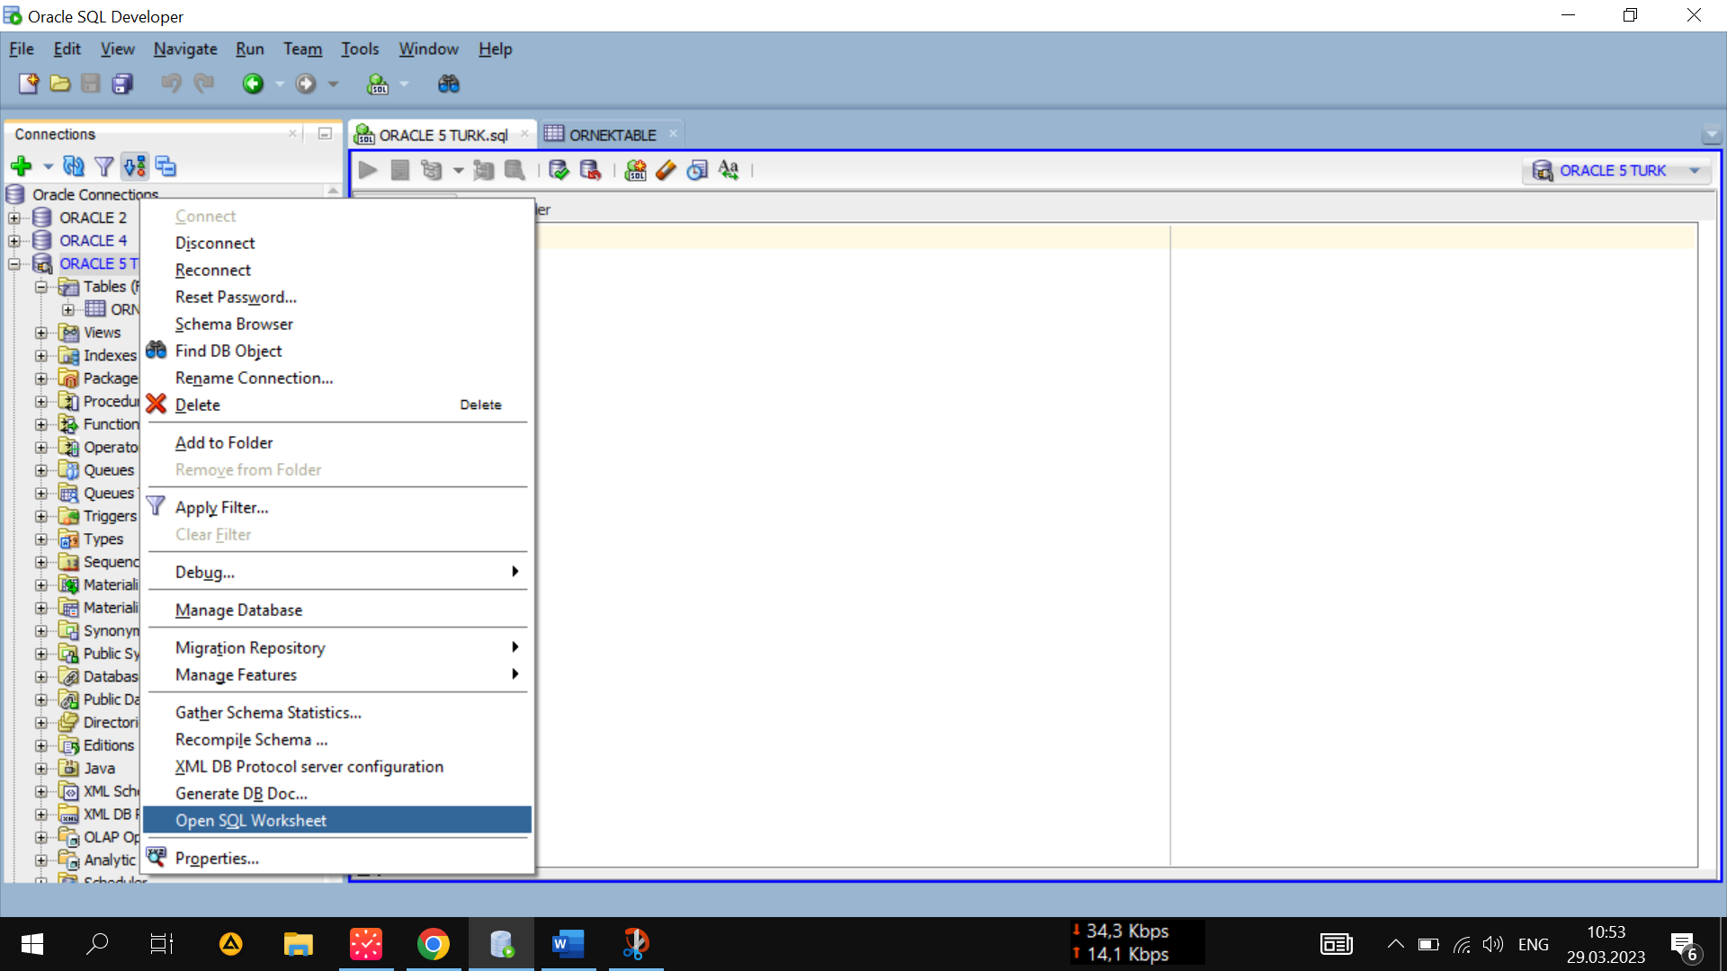

*Properties* qismida *user*ning profiliga o’zgartirish kiritish mumkin.

# Working with Database Object

## Create Table with SQL

Yozilgan kodlarning formatini to’g’irlash uchun: **Ctrl + F7**

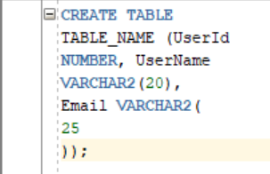 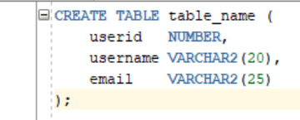

(yoki kodni ustiga o’ng knopka bosiladi va *Format* belgilanadi.)

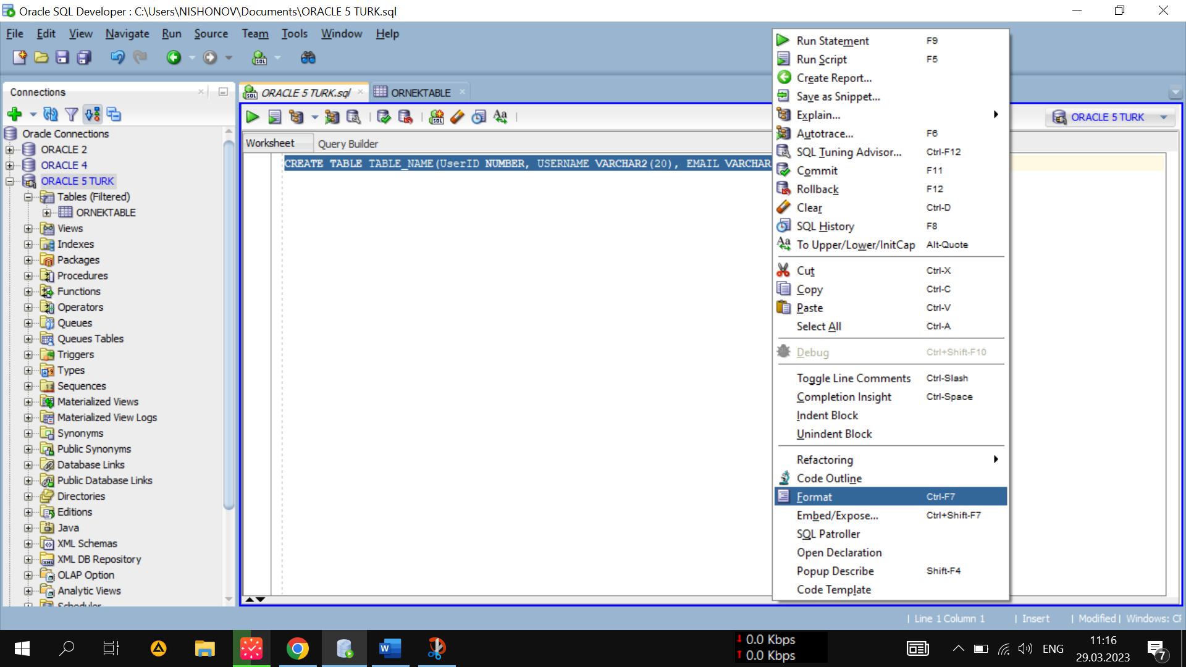

Yaratilgan jadvalni *Tables*da ko’rish uchun:

(*Tables*ga o’ng knopka bosilib, *Refresh* belgilanadi.)

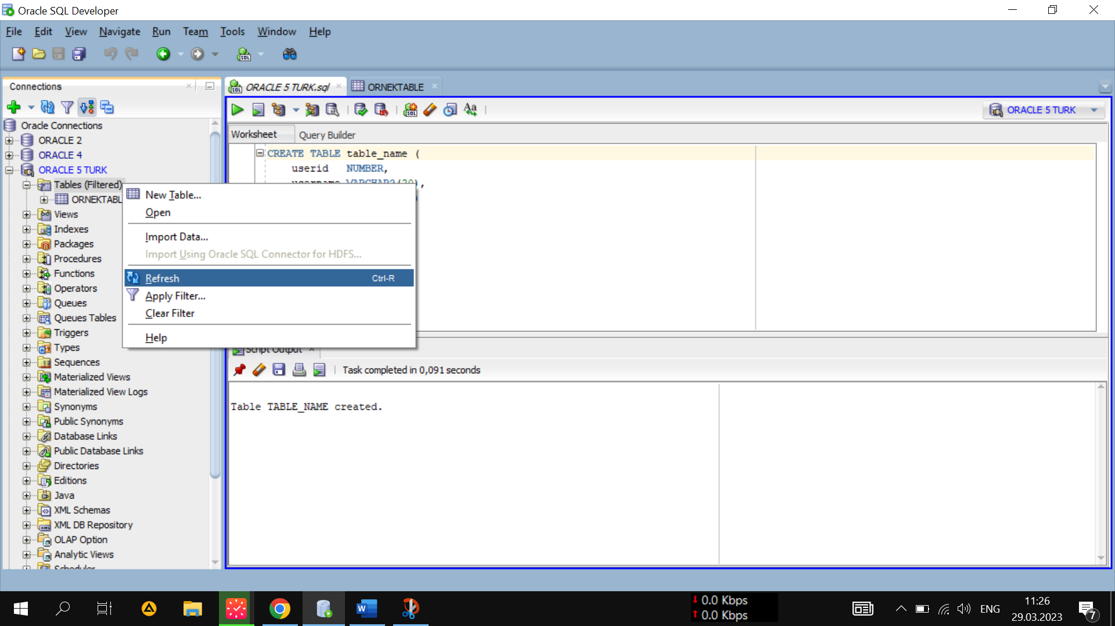

## Creating Tables Using Table Dialog

Jadvalni kodsiz oson yaratish:

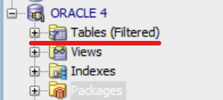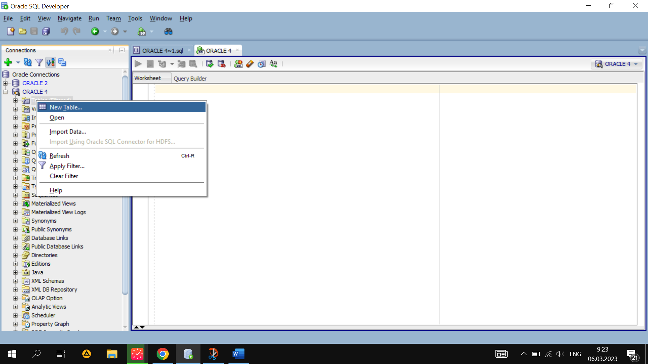

*Tables*ga mishkaning o’ng knopkasi bosilib, *New_Table* bosiladi.

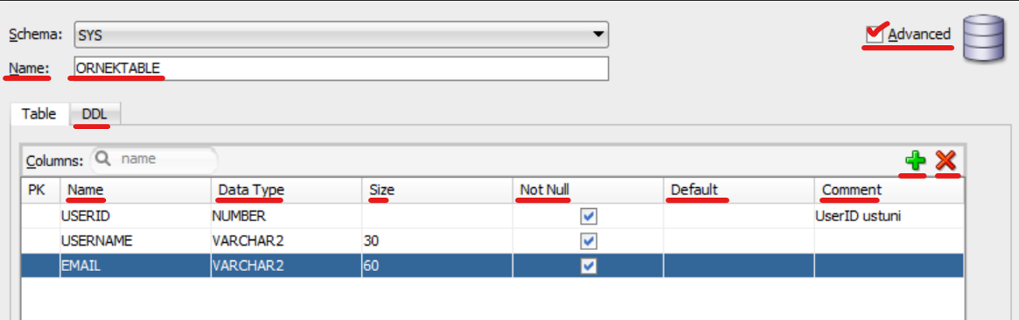

Jadval nomi va har xil o’lchovlari kiritiladi.

+ ustun qo’shish

X ustun o’chirish

DDL — ushbu bajarilgan operatsiyaning kodlari.

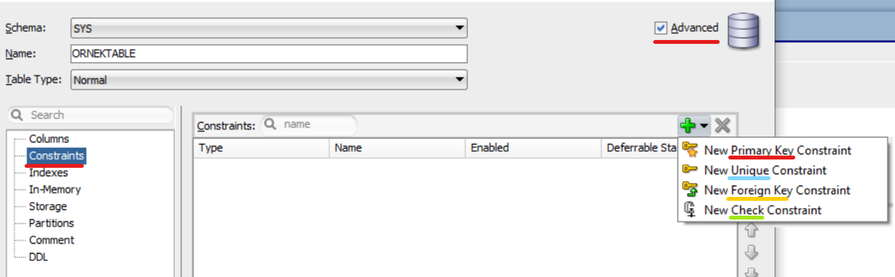

Constraints => cheklovlar o’rnatish

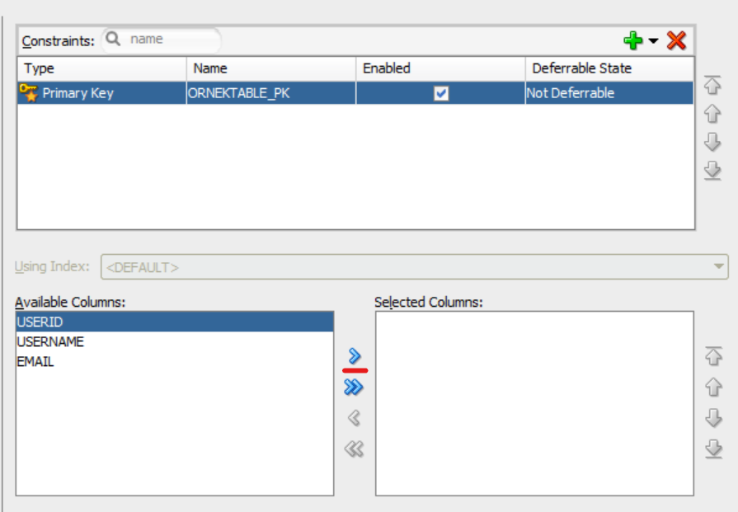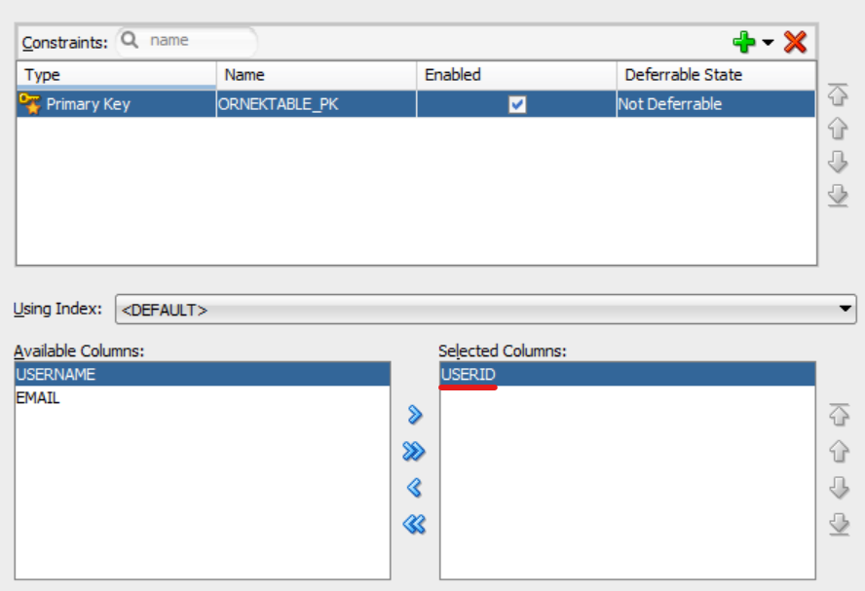

Jadval haqidagi ma’lumotlar:

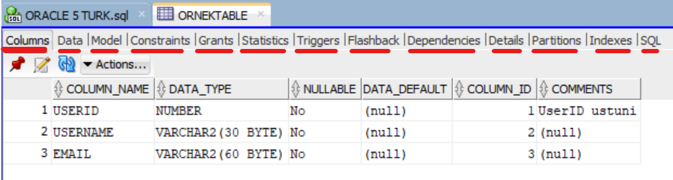

Columns 🡺 Ustunlar

Data 🡺 Ma’lumotlar

Model 🡺 Jadval struktura modeli

Constraints 🡺 Cheklovlar

Grants 🡺 Imtiyozlar (ruxsatlar)

## Copy Table to Table and SQL Dialog

Jadvaldan nusxa olish:

Kerakli jadval ustiga o’ng knopka bosiladi 🡪 Table 🡪 Copy

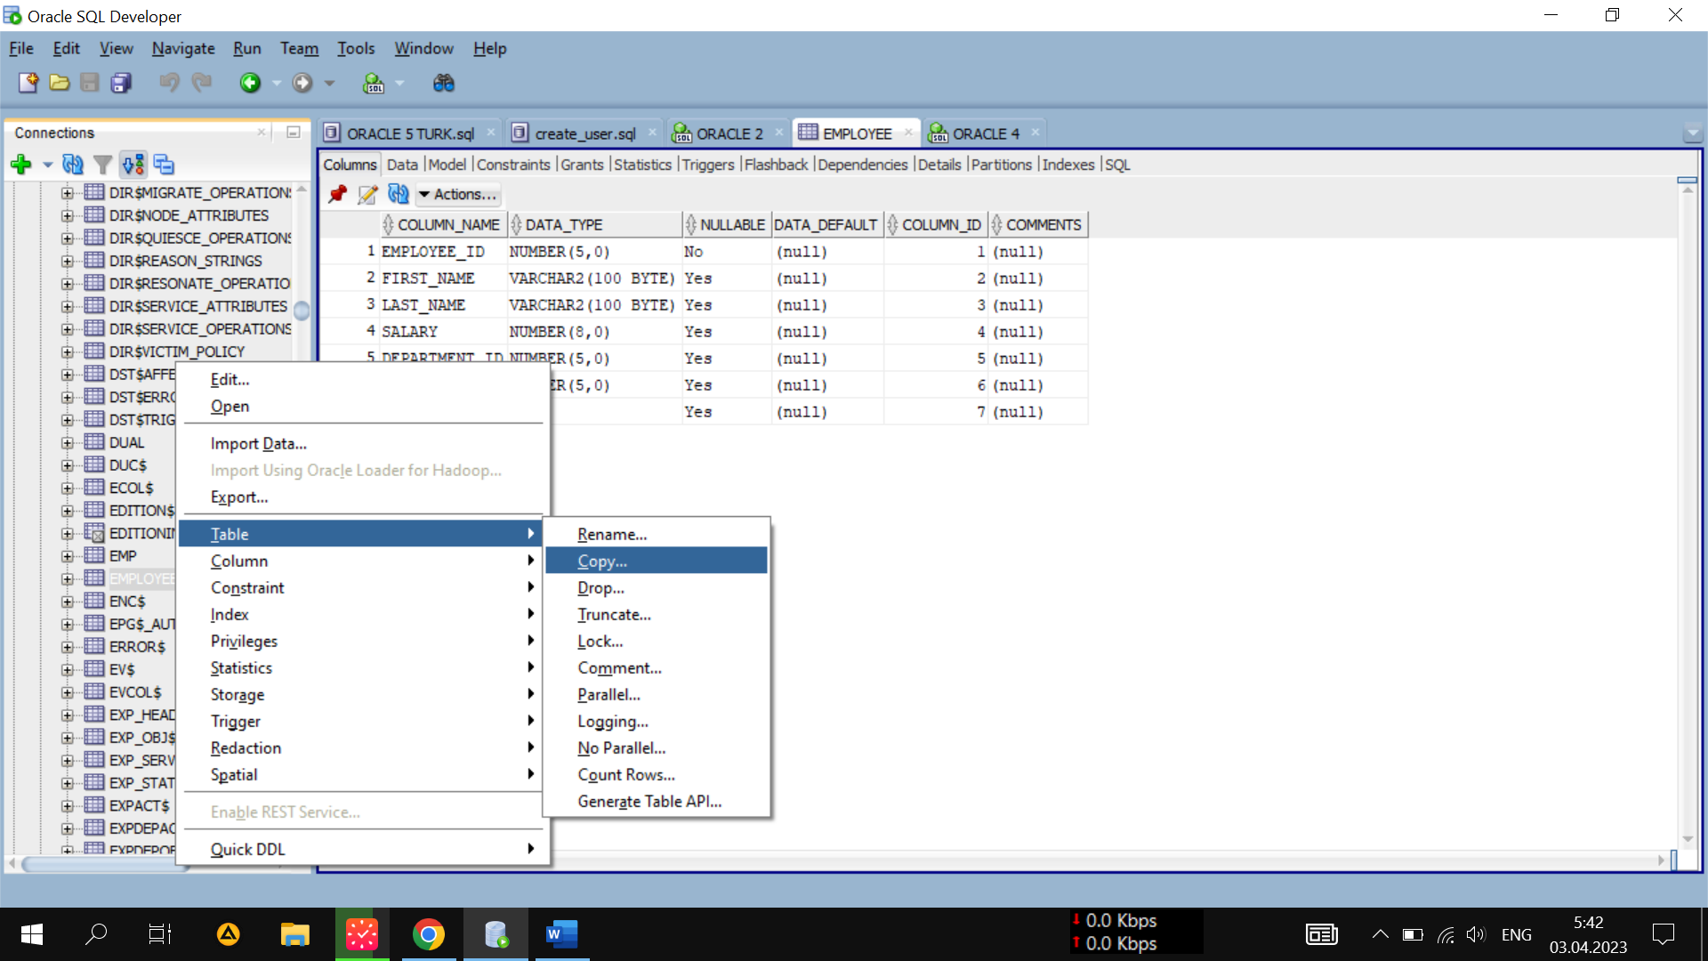

Owner ⬄ Egasi (baza nomi)

New Table Name ⬄ Yangi jadval nomi

Include Data ⬄ Ma’lumoti bilan qo’shib nusxa olish

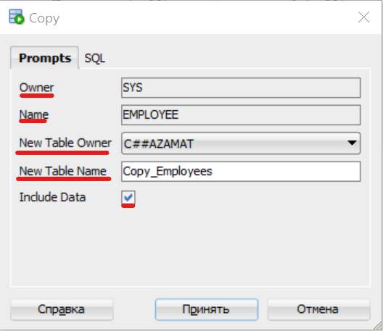

Baza ichidagi jadvaldan nusxa olish kodi:

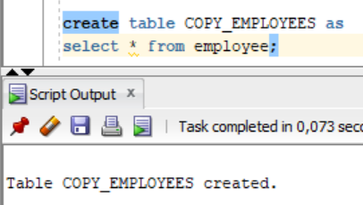

Jadvalni o’chirish:

Kerakli jadval ustiga o’ng knopka bosiladi 🡪 Table 🡪 Drop

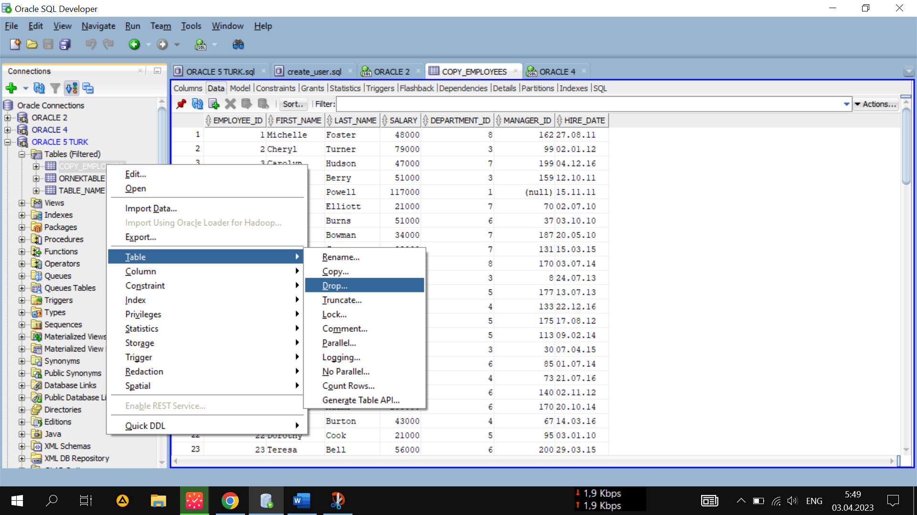

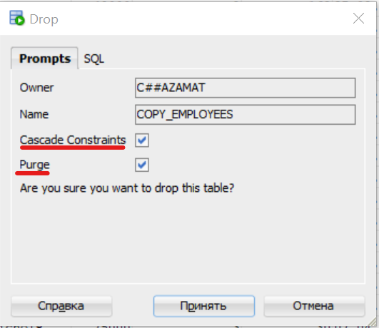

## Adding a new column to the table

Yangi ustun qo’shish:

Kerakli jadvalga o’ng knopka bosiladi 🡪 Column 🡪 Add

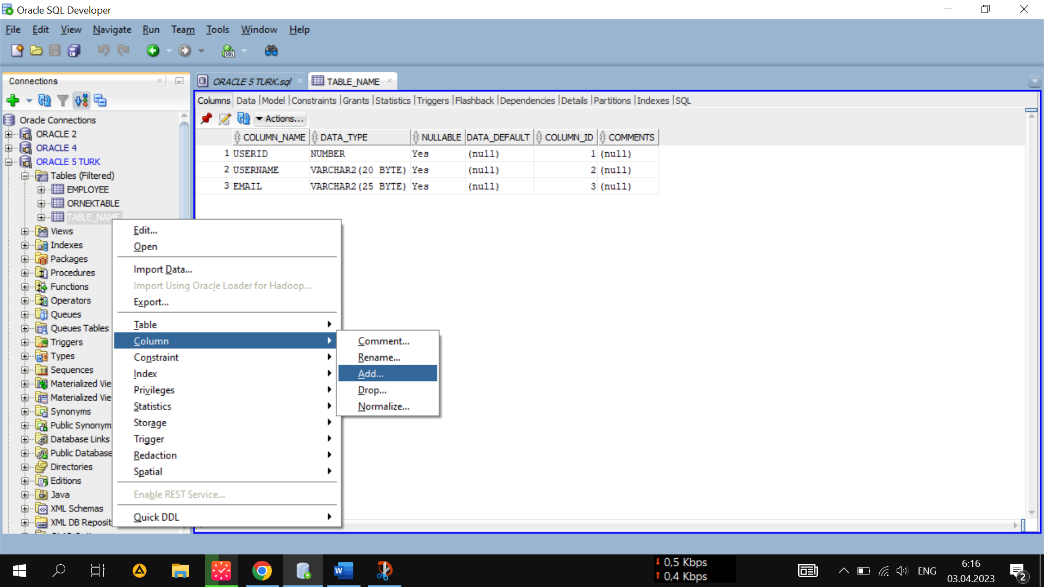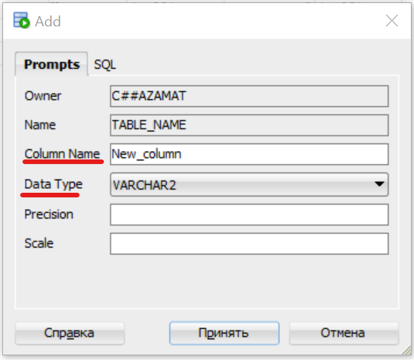

# Data access

## Receive Columns

Kerakli kod copy qilinadi:

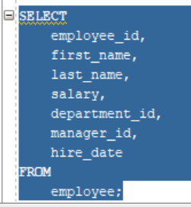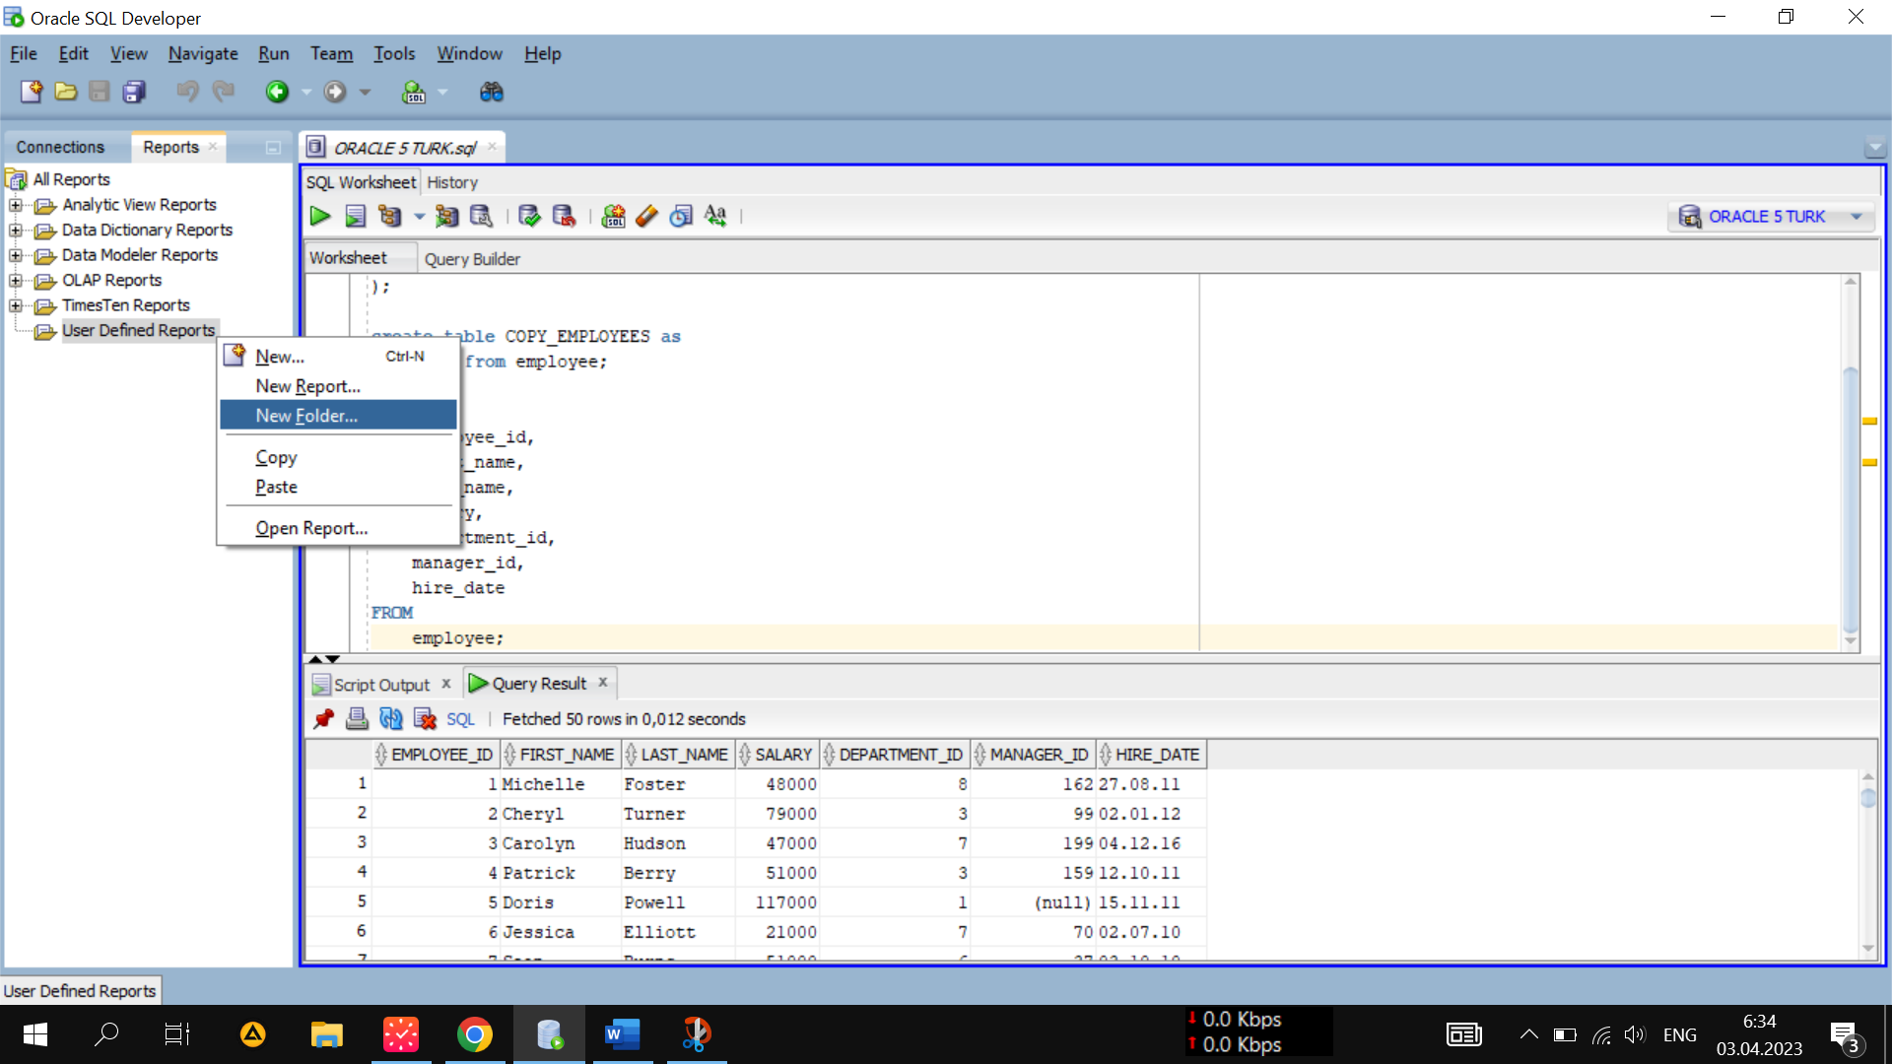 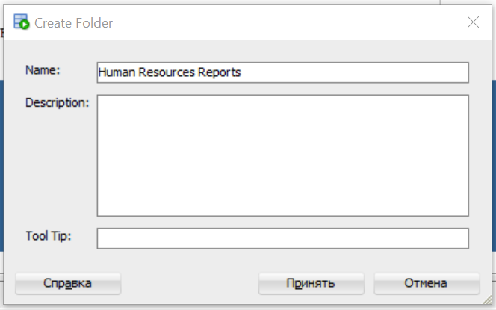

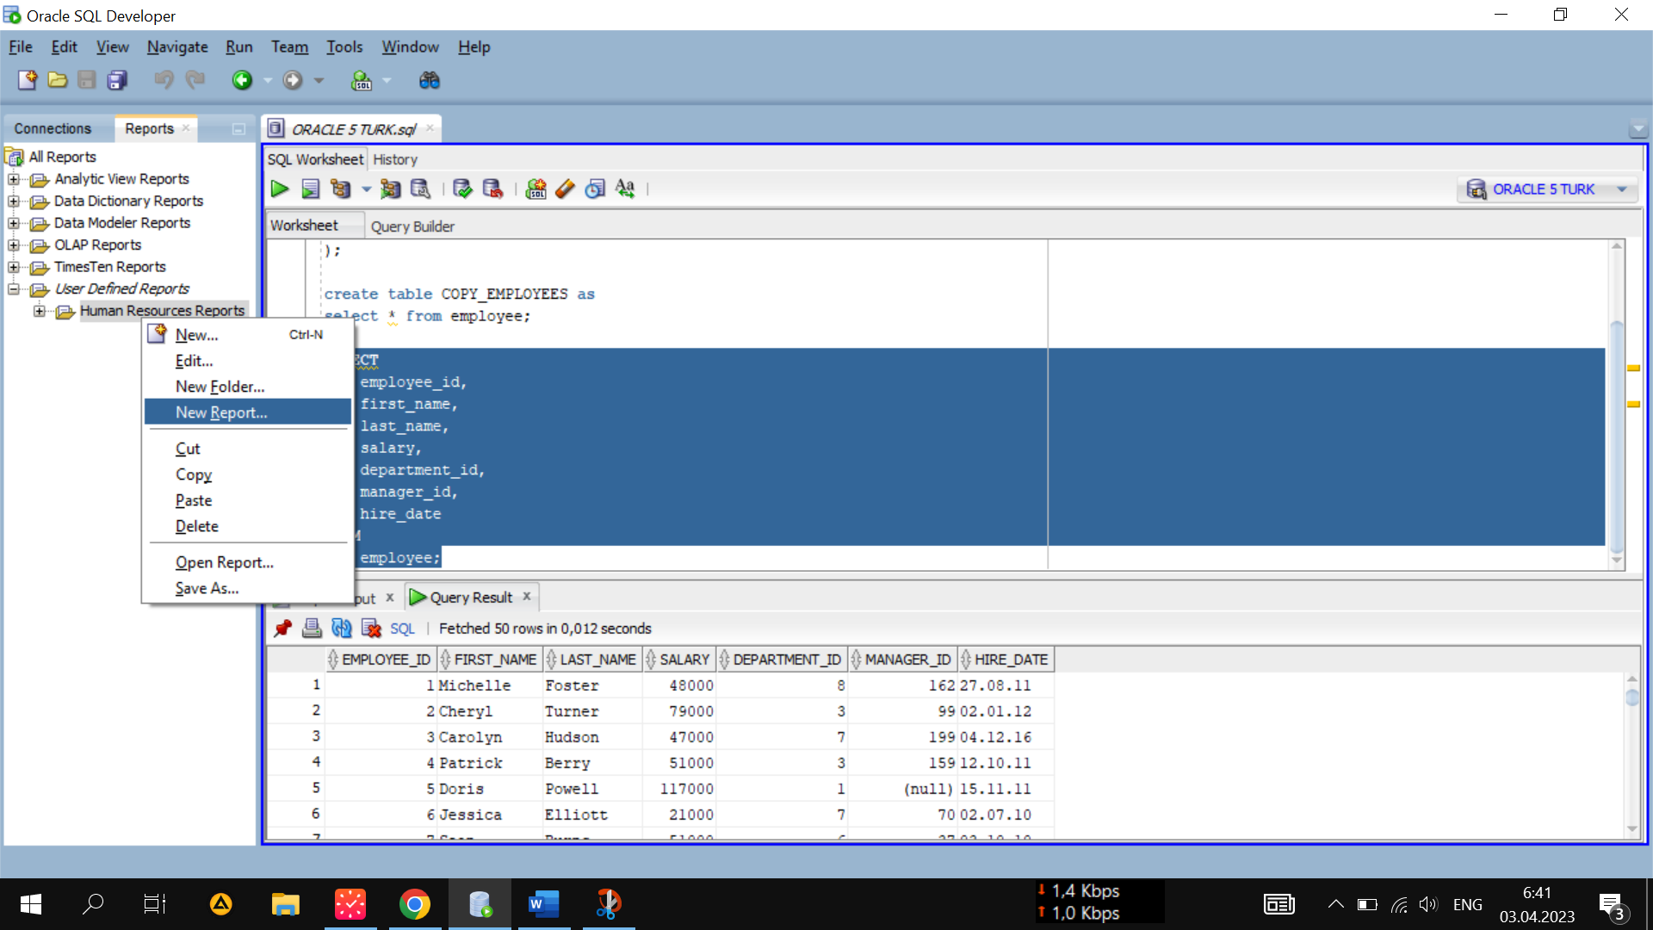

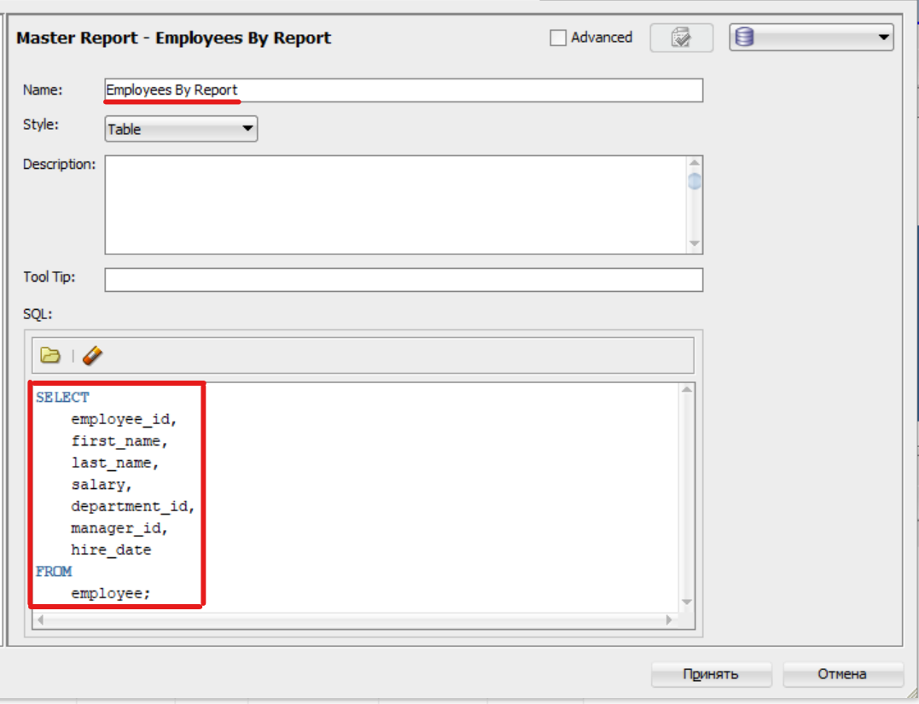

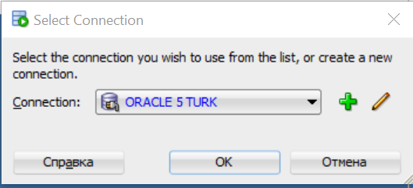

## Getting rows

O’zimiz istagan qiymatni tanlab chiqarish: { VALUE or NULL }

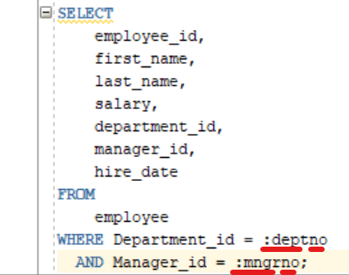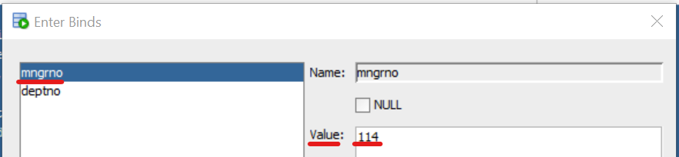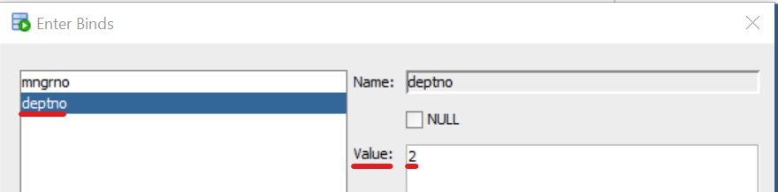

*deptno* 🡺 departmenet_id nomerini kiritishni anglatadi.

*mngrno* 🡪 manager_id nomerini kiritishni anglatadi.

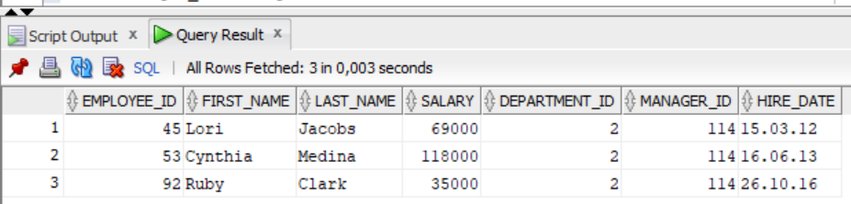

## Oracle Sql Query Builder

Query builder 🡺 kod yozib beruvchi:

{ Kerakli jadval tanlanib, o’ng tarafga olib o’tiladi }

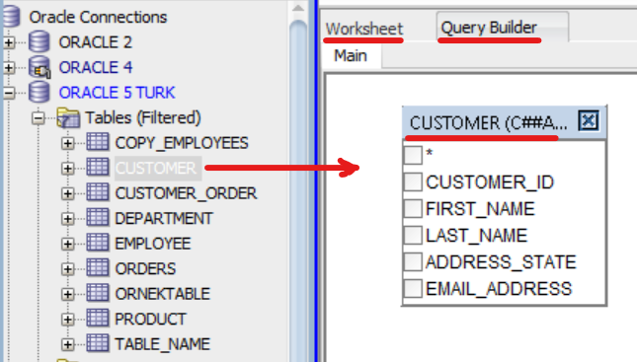

Sarlavhadagi *CUSTOMER*ni 2 marta bosib, unga taxallus qo’yamiz:

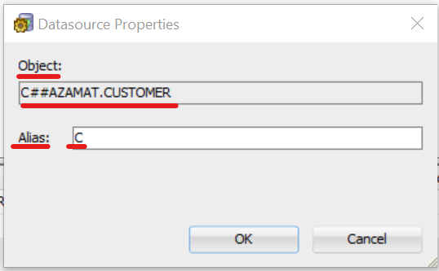

Query builder tuzgan kod:

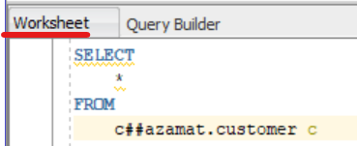

Kerakli ustunlarni tanlab chiqarish va shartlar kiritish:

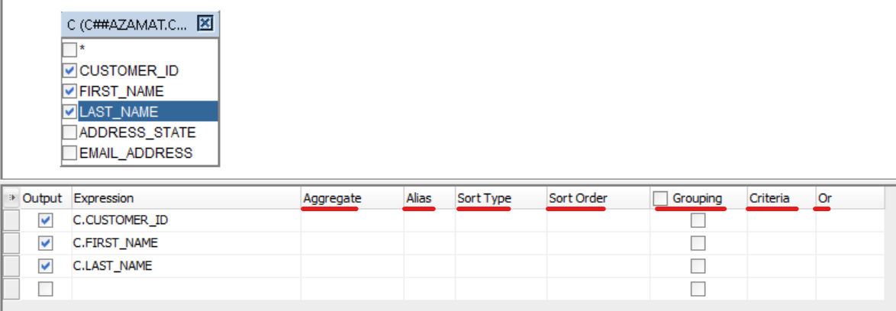

Hosil qilingan kod:

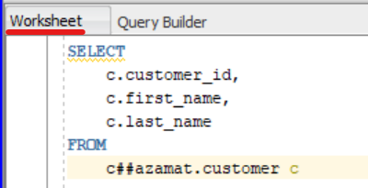

***Inner Join*** qilish: { 1-ustunni ushlab, 2-ustun ustiga tashlaymiz }

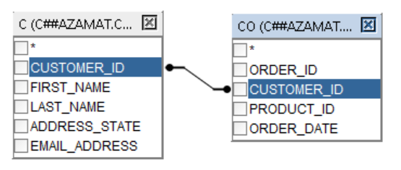

Left Join, Right Join va Full Join qilish:

* Left Join 🡺 Select all rows from C
* Right Join 🡺 Select all rows from CO
* Full Join 🡺 ikkovi ham belgilanadi

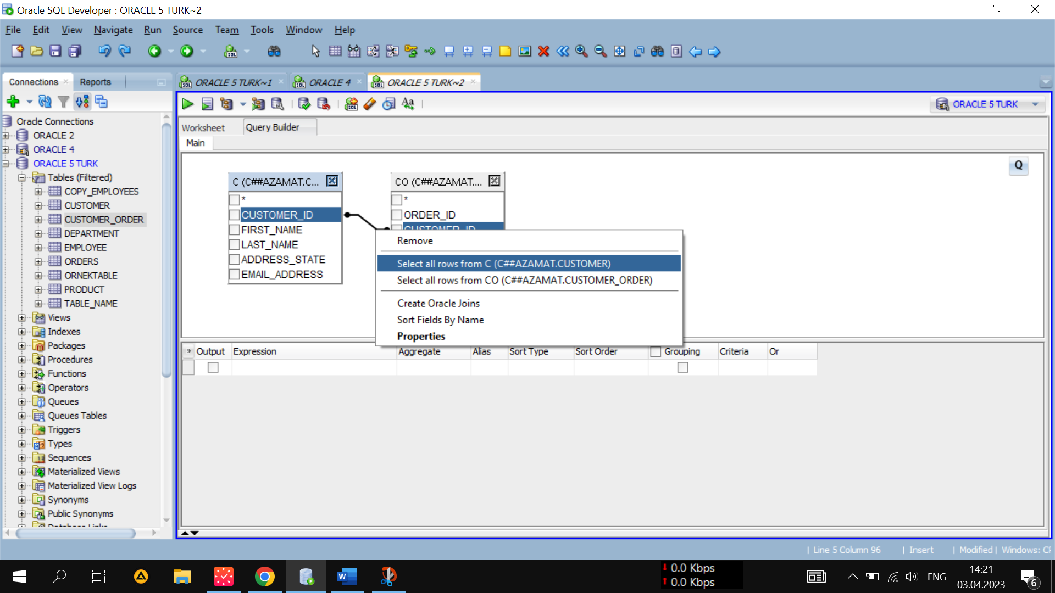

## JOIN’s Understanding

Jadvallarni mixlab qo’yish uchun:

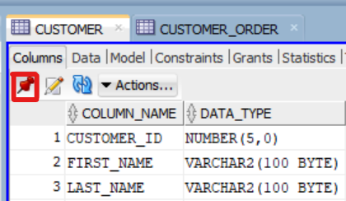

Natural Join:

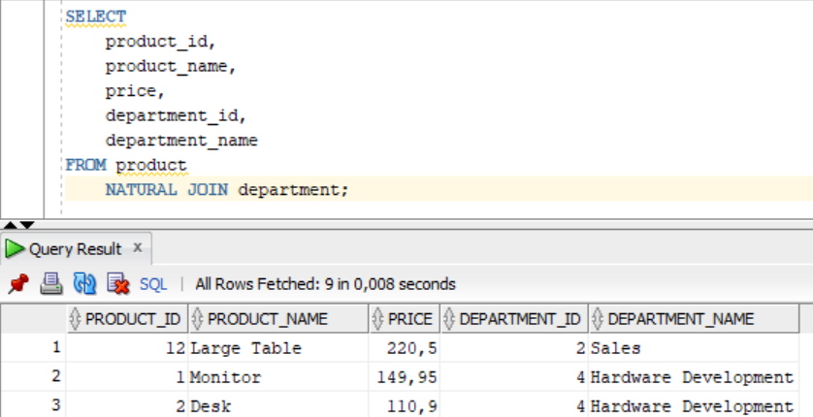

## ON CLAUSE with the JOIN operation

JOIN operatorining ON bandi

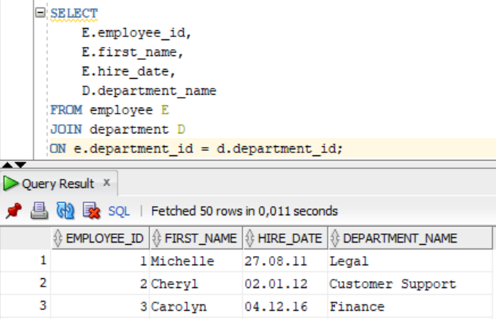

## Writing a Query That Joins Multiple Tables

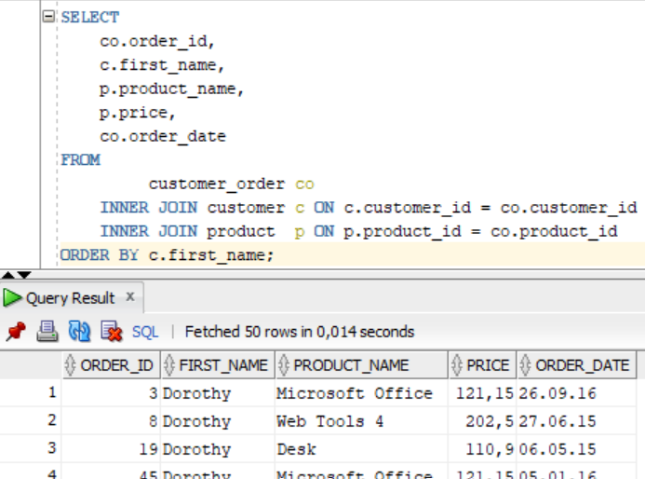

## Character functions

Functions ga kirish: View 🡪 Snippets

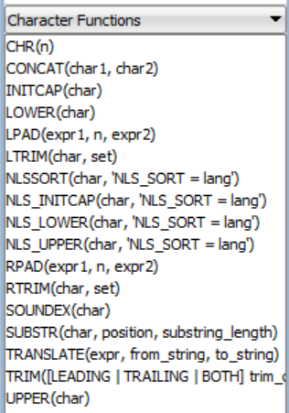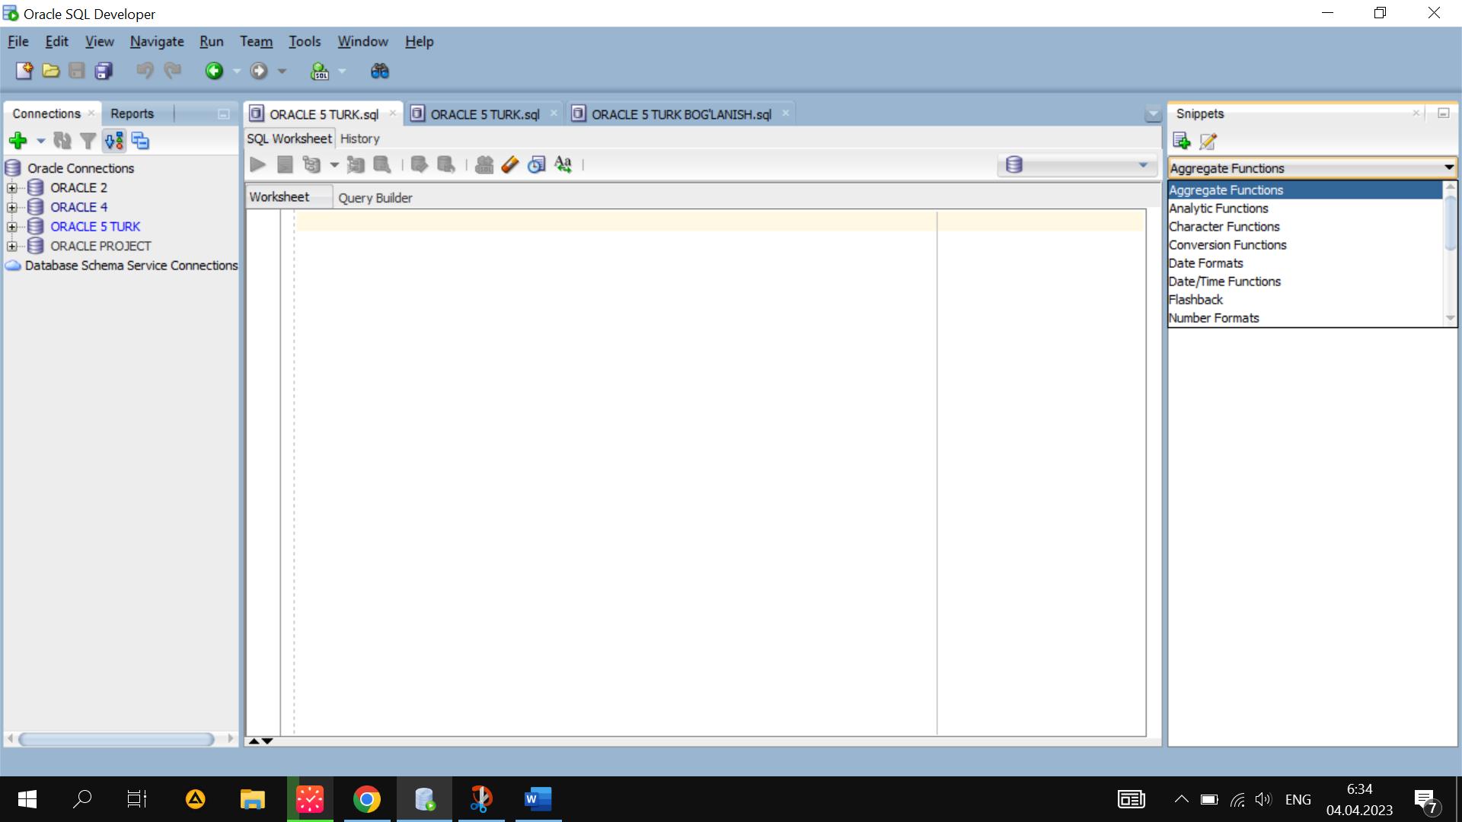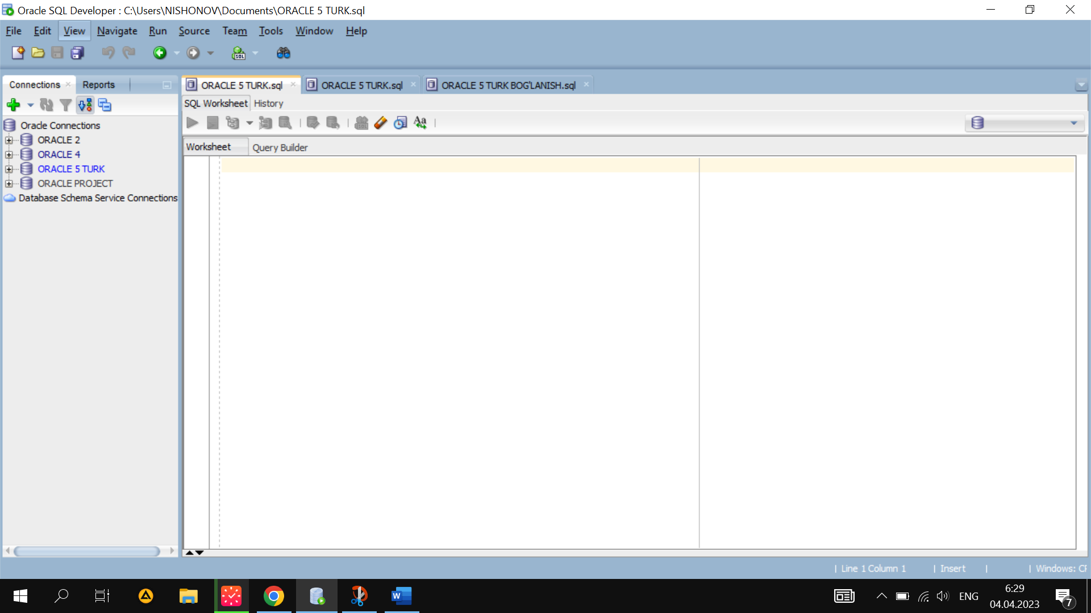 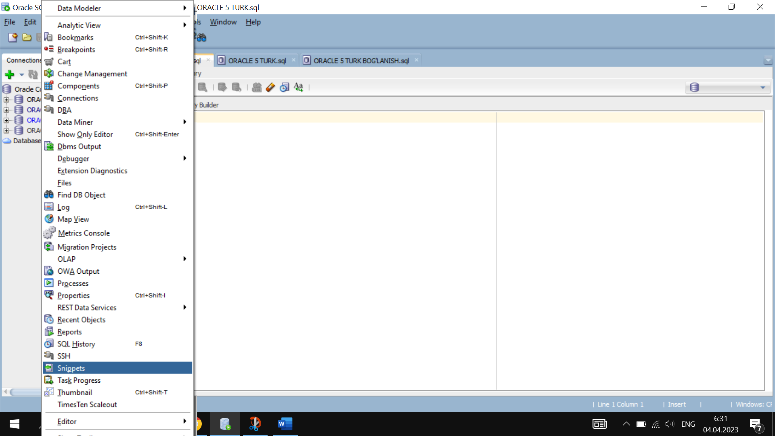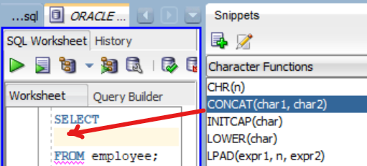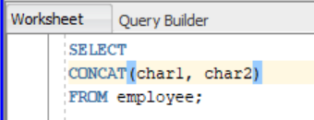

## Numeric Functions

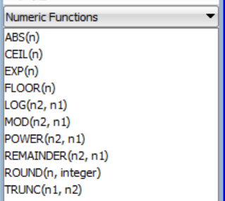 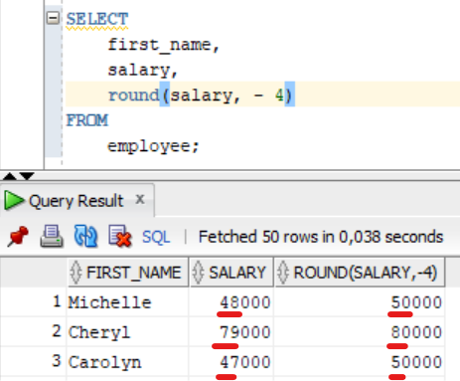

## Date/Time Functions

Kunlar farqini hisoblash:

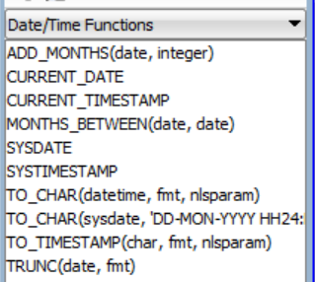 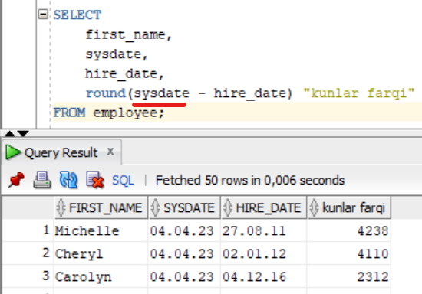

Necha yil ishlaganini hisoblash:

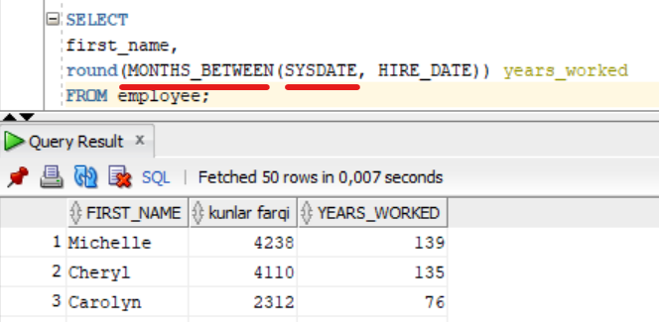

## Date Formatting

Ishga kirish sanasini belgilar bilan chiqarish:

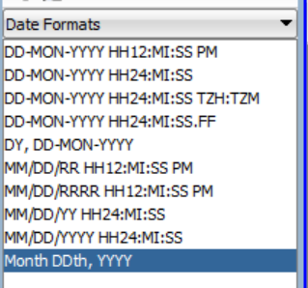 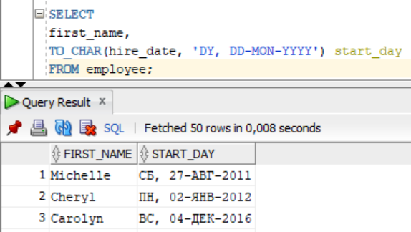

## NVL Functions

Conversion Functions 🡪 NVL Function

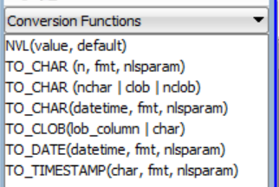 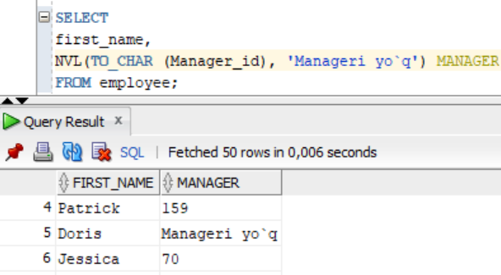

## Use of Group Functions

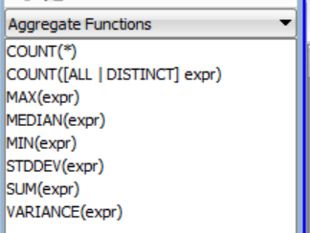 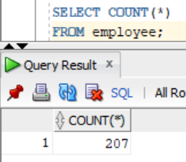

## Grouped Data Reports

Guruhlangan ma'lumotlar hisobotlari:

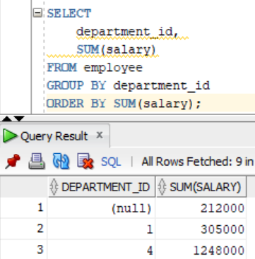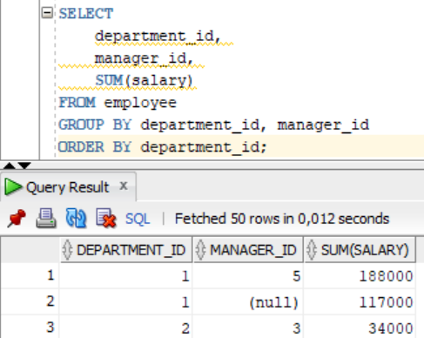

## Use the HAVING clause

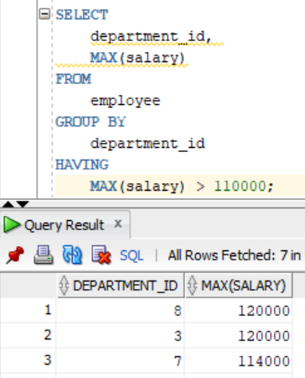

# Data Processing

## Add Single Line Data

#### **Ma’lumotlarni kodsiz kiritish:** { Ctrl +I }

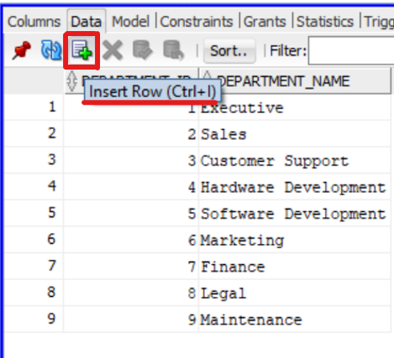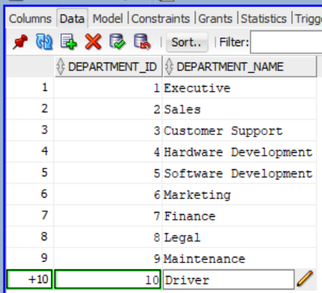

#### O’zgartirishni soxranit qilish: COMMIT { F11 }

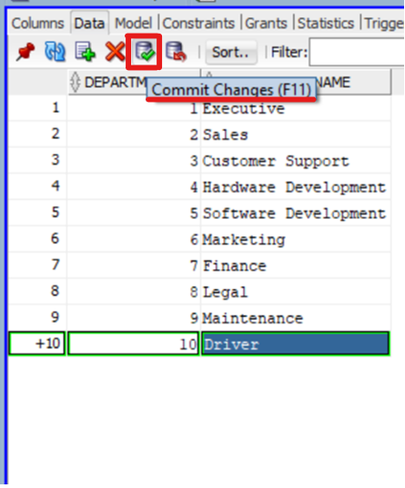

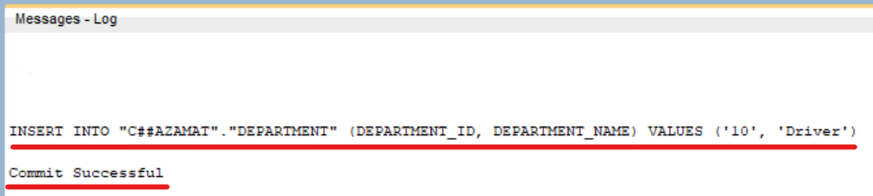

#### O’zgartirishni bekor qilish: ROLLBACK { F12 }

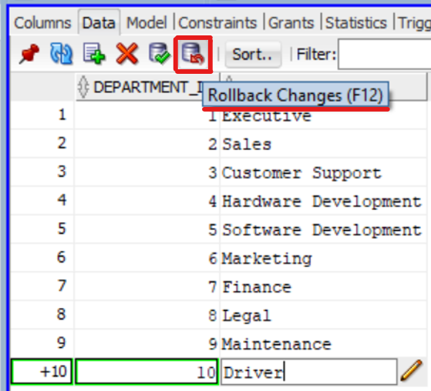

## Adding Multi-Line Data

Barcha kodni birdaniga ishlatish: Run Script 🡪 { F5 }

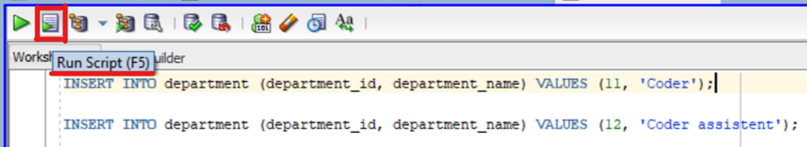

## Update Data

O’zgartirish kiritamiz + Commit:

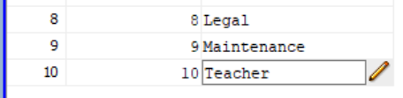

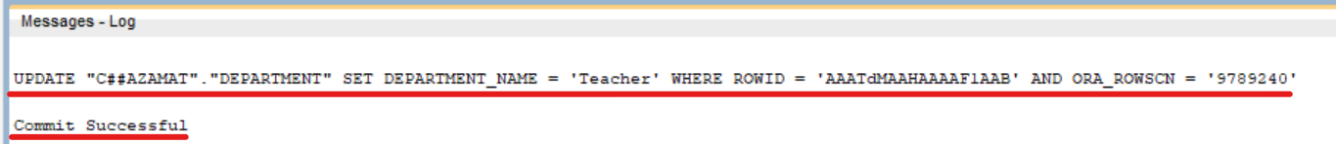

## Delete Data

#### Kodsiz ma’lumotli qatorni o’chirish: { Ctrl + D }

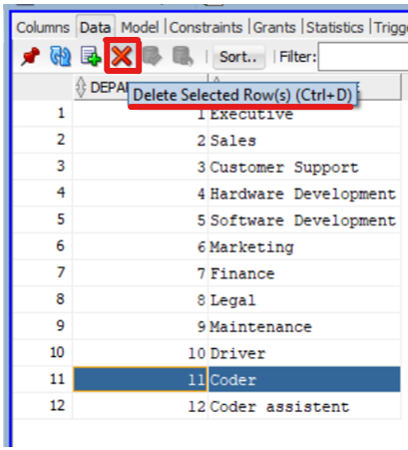

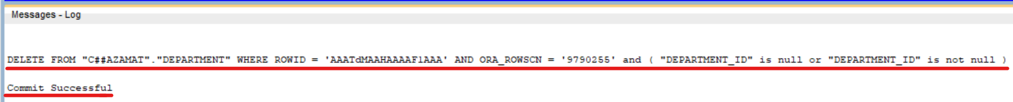

#### Filter

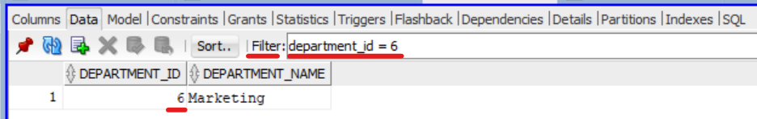

## Excel to Export

Data ustiga o’ng knopka bosiladi 🡪 Export

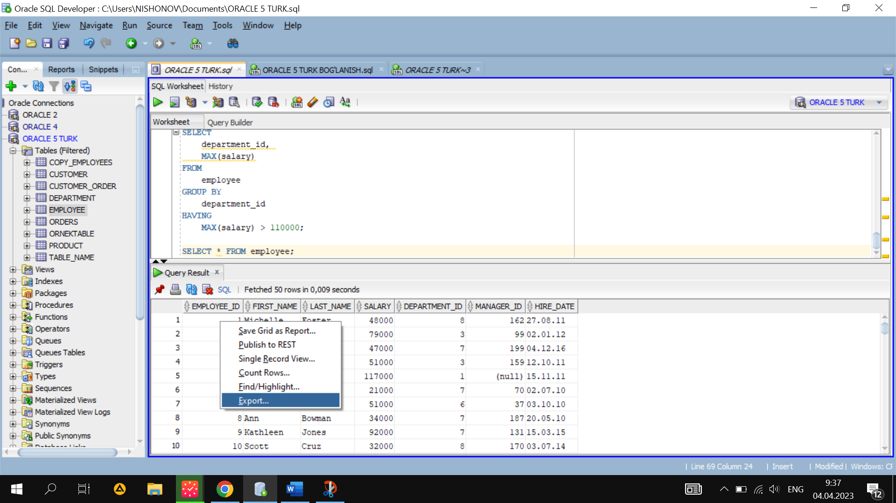 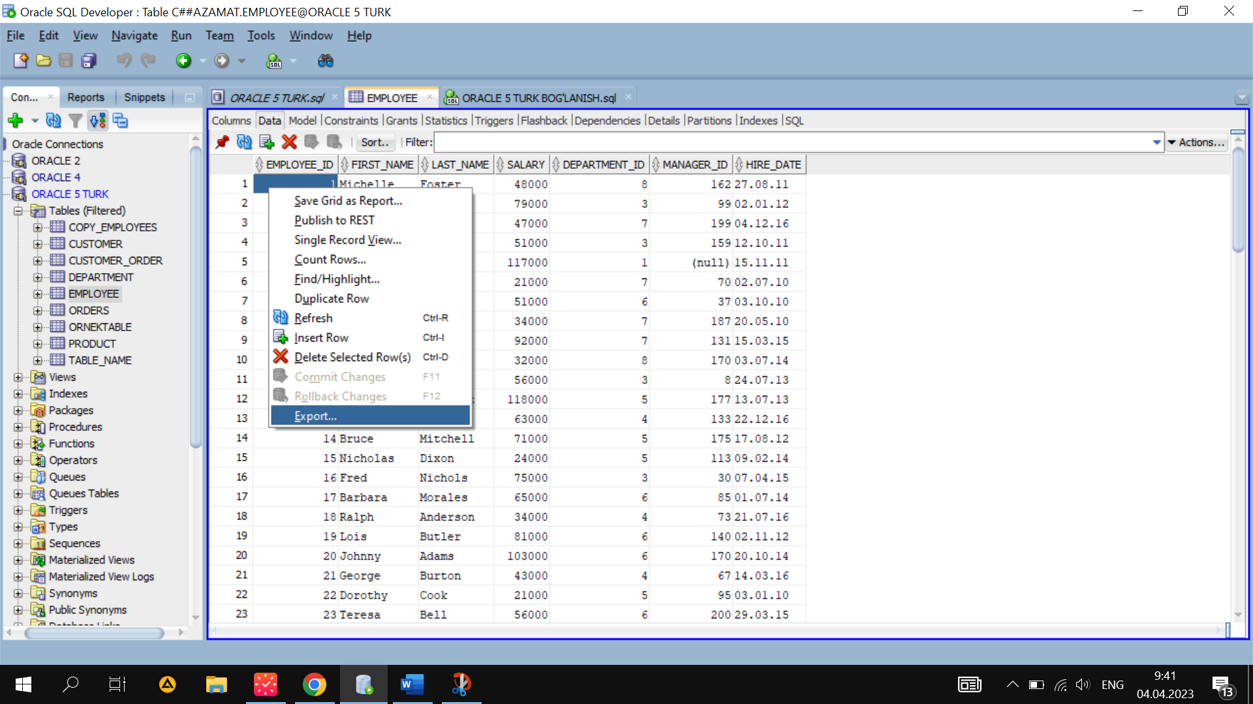

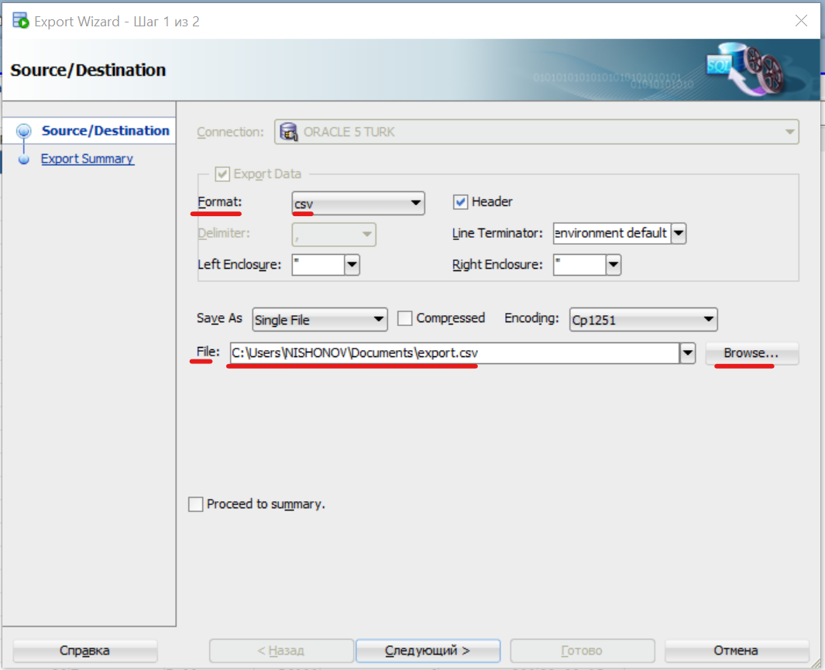

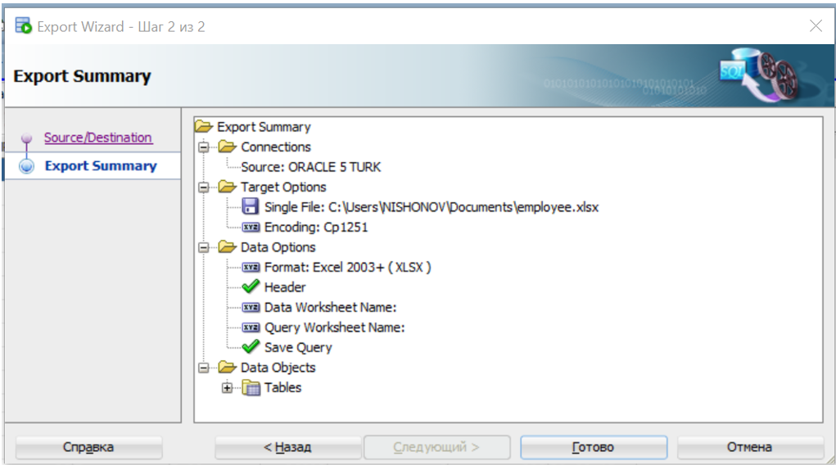

## Export to DDL

Tools 🡪 Database Export

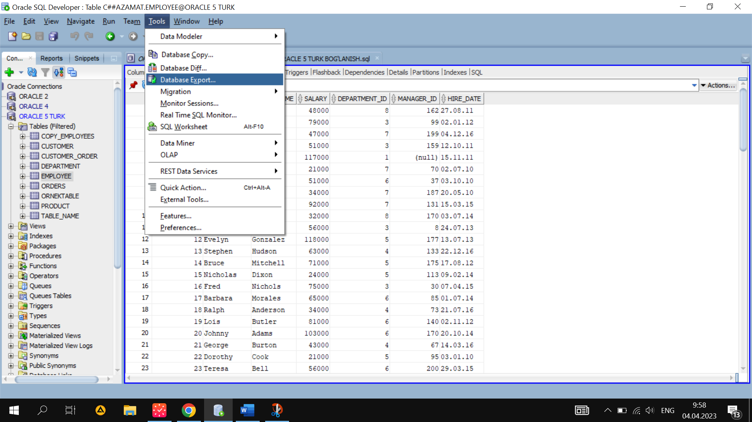

Source / Destination ⬄ Manba / Manzili

Connection ⬄ baza nomi

File ⬄ joylashuv joyi

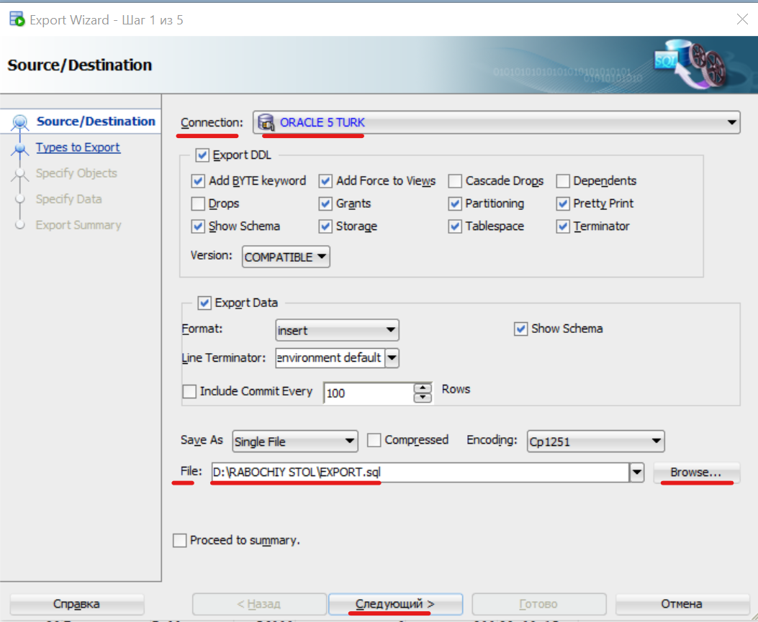

Types to Export ⬄ Export qilinadigan turlar

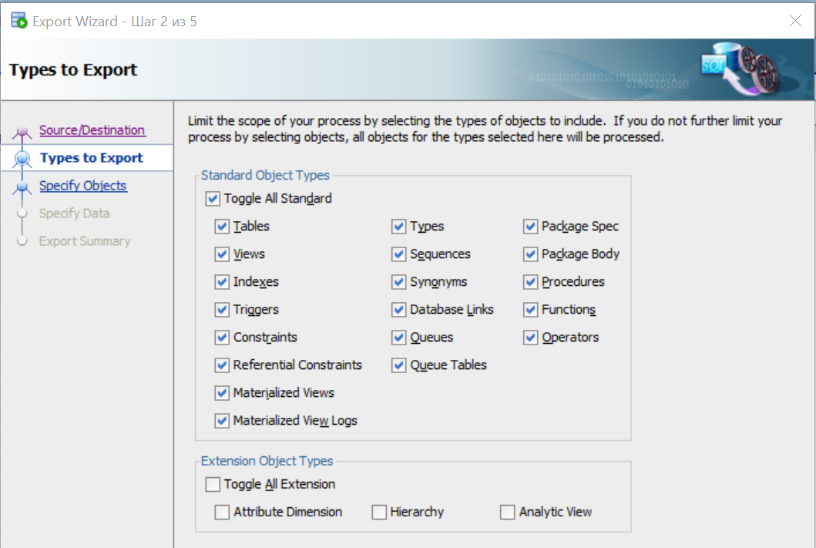

Spesify Objects ⬄ Obyektlarni belgilash:

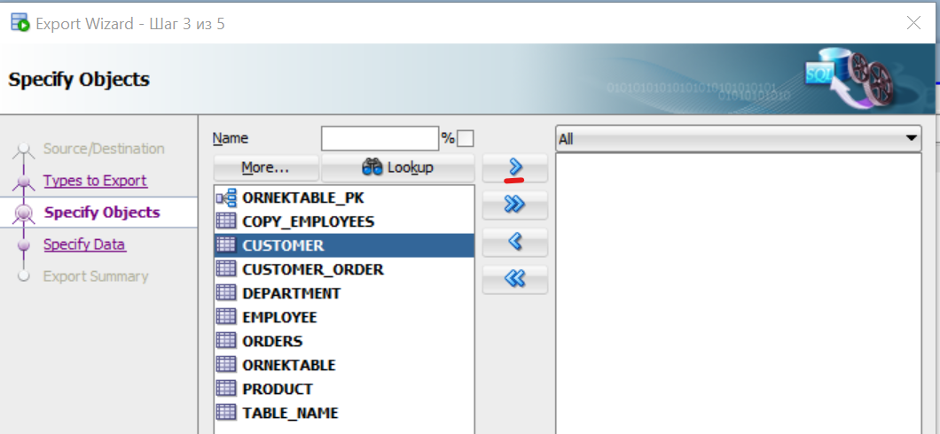

Tayyor.

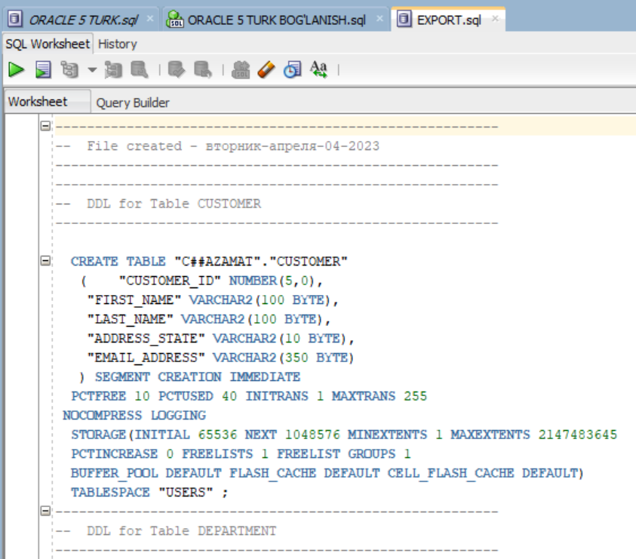

# Adding components PL/SQL

## Create DML Trigger

#### Create TRIGGER 1-usul

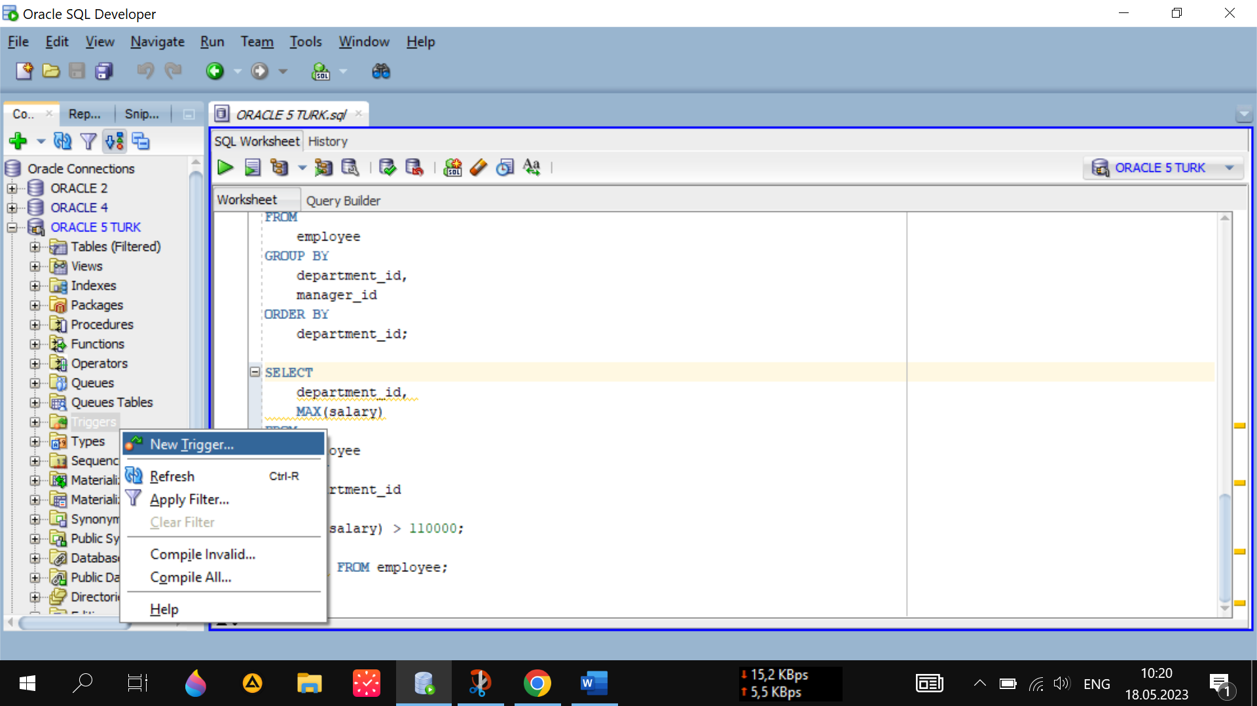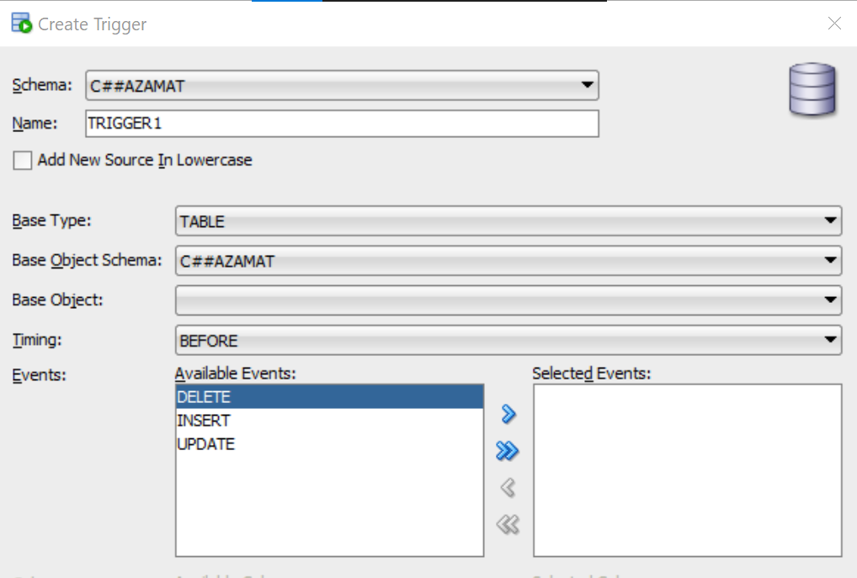

#### Create TRIGGER 2-usul

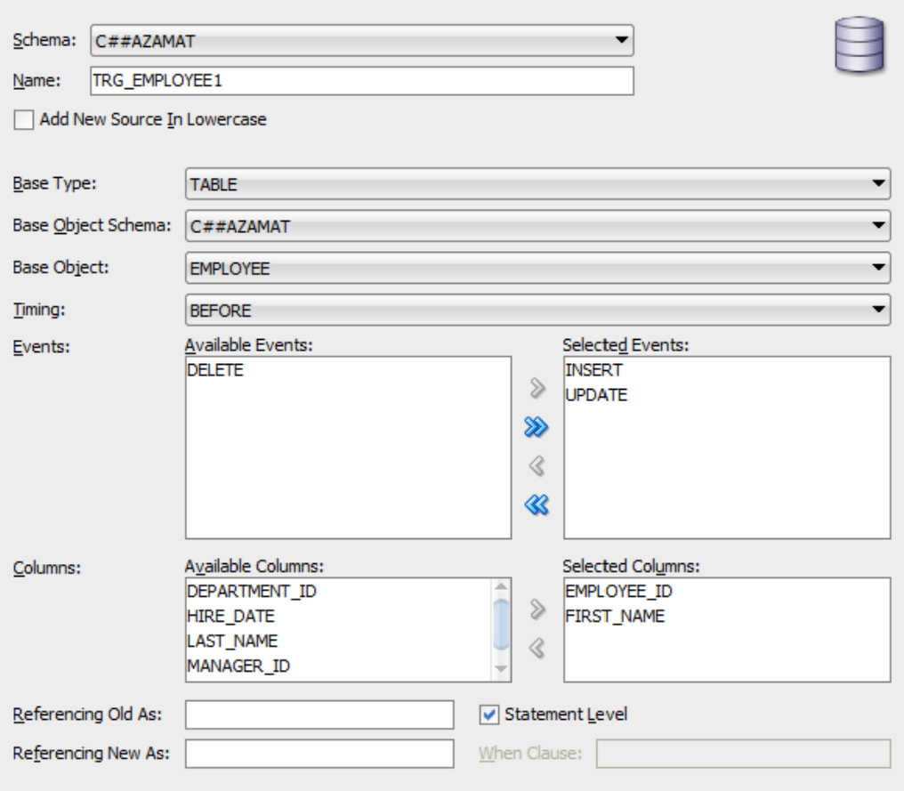

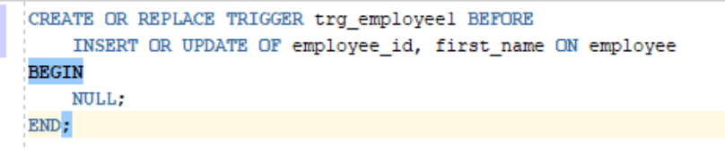

## Manage Trigger

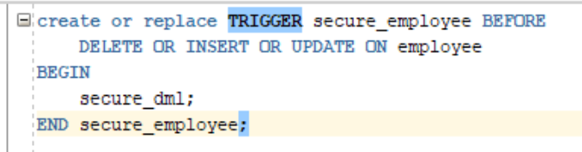

Komplyatsiya qilish:

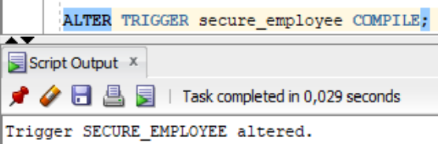

Enable:

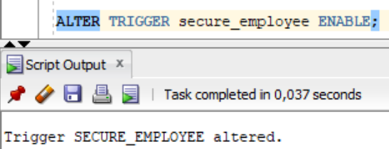

Disable:

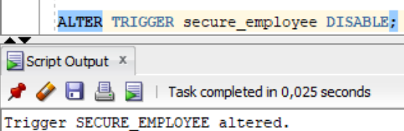

Disable All Triggers:

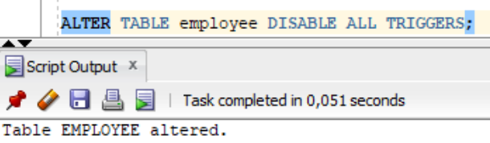

## Create Stored Procedure

Create Procedure:

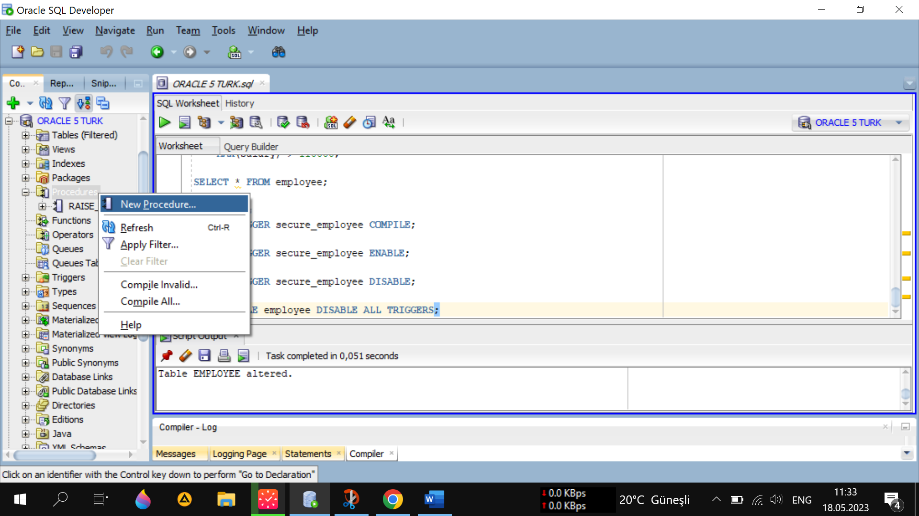

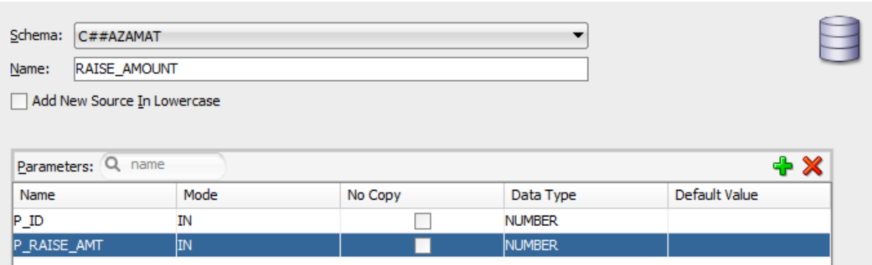

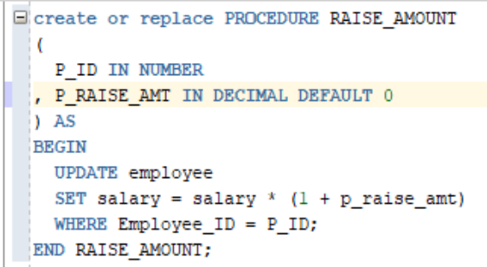

Komplyatsiya:

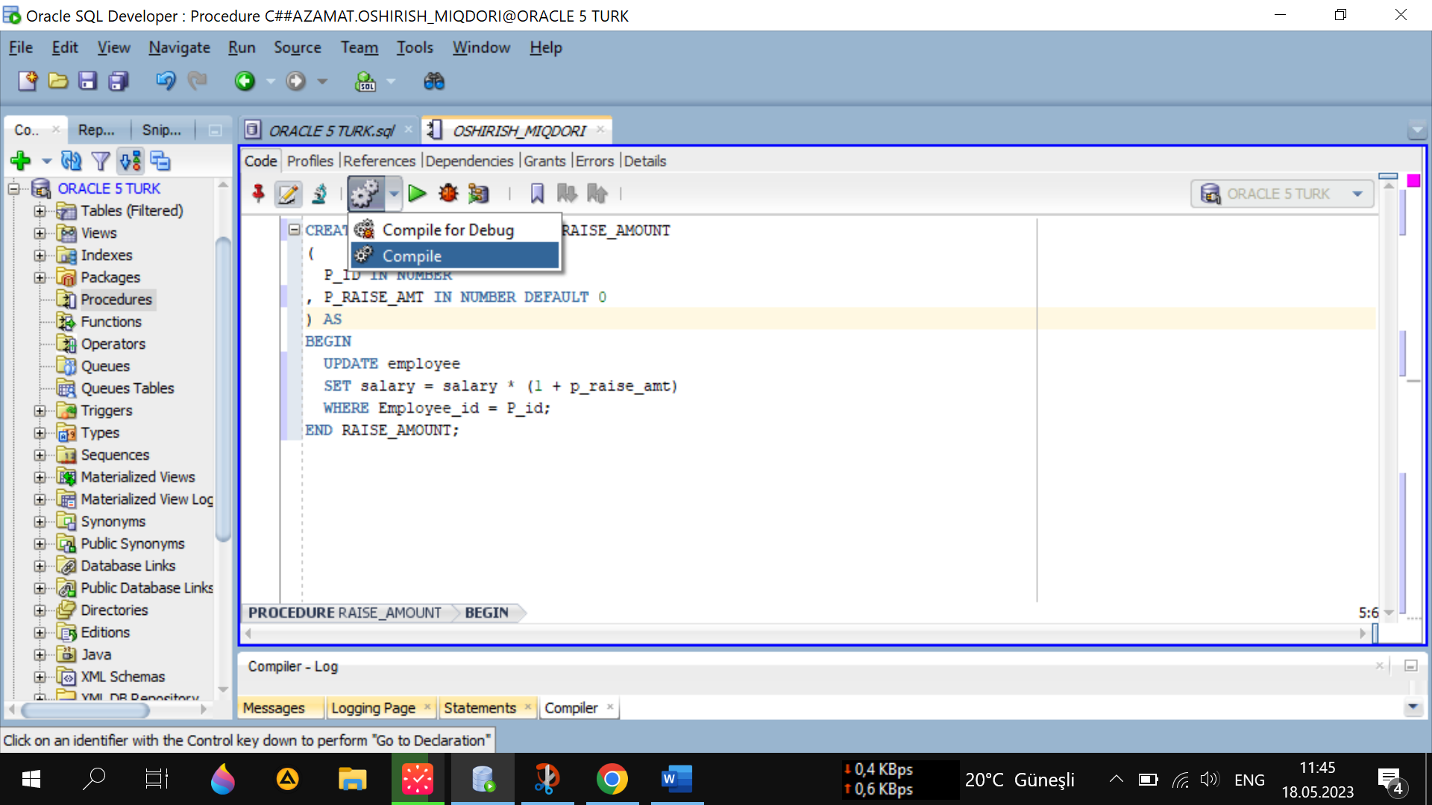

#### Protsedurani ishlatish

Salaryni aniqlaymiz:

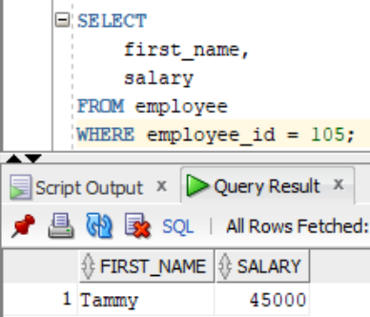

Qiymatni o`zgartiramiz:

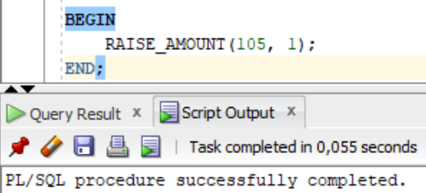

Natijani tekshiramiz: Salary 1 baravar oshdi.

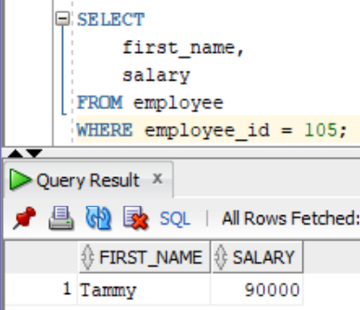

## Use of Function

Create Function

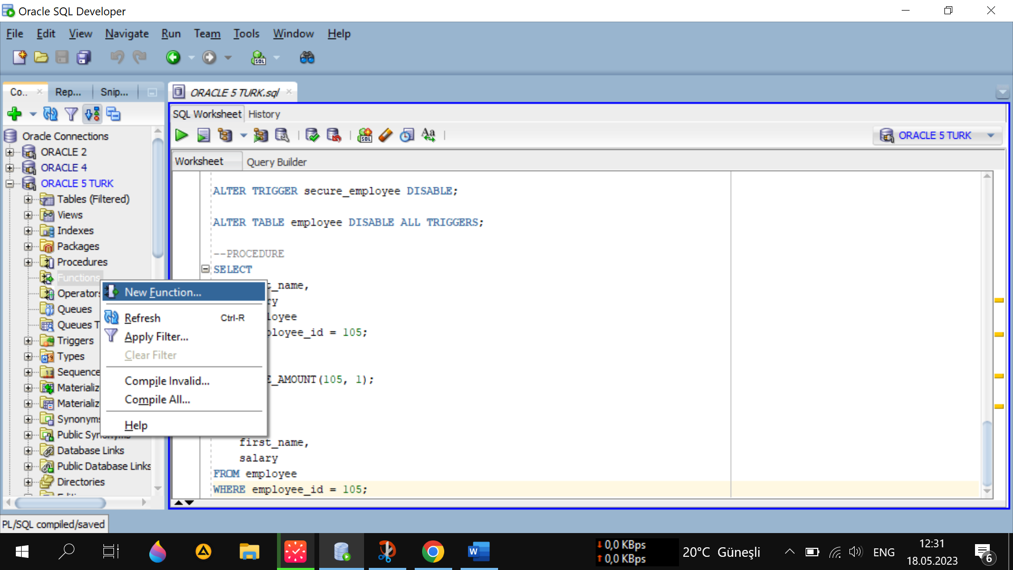

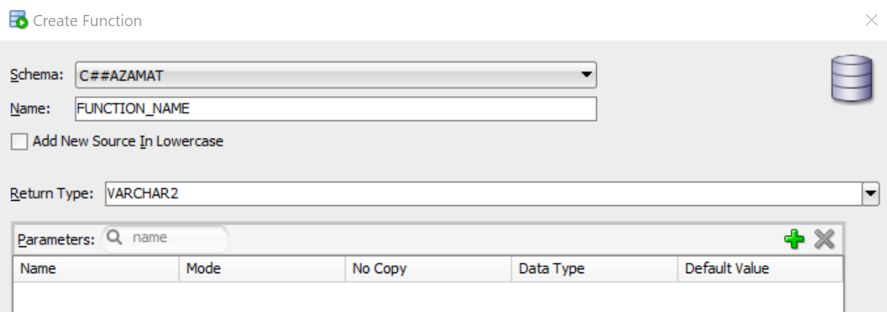

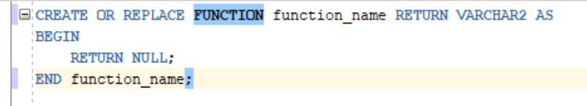

#### Get_Sal nomli funksiya yaratish

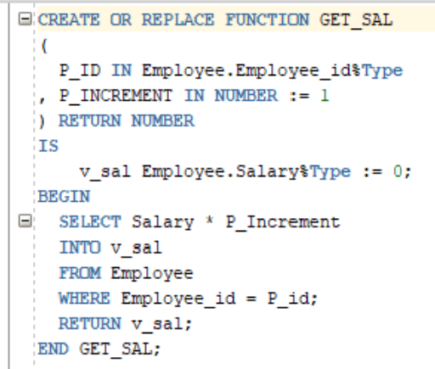

Komplyatsiya:



Funksiyani ishlatamiz: Salary ning qiymati oshirilib taklif qilinmoqda.

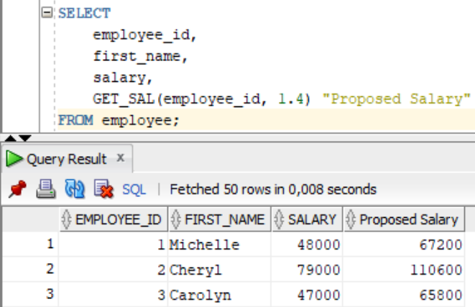

# SYNONYM

Create Synonym:

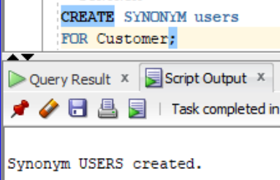

Customer jadvalini chiqaramiz:

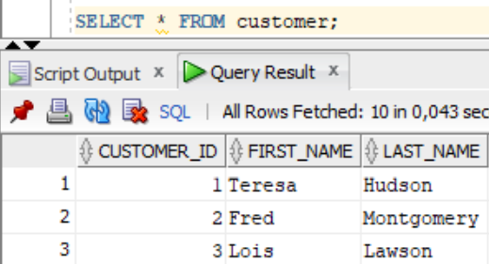

Usersni tekshiramiz: ikkovi aynan bir xil

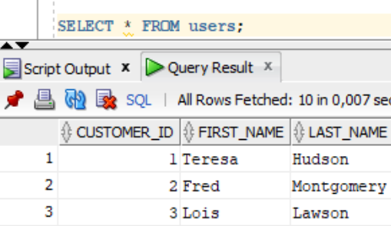

Usersga ma’lumot kiritamiz:

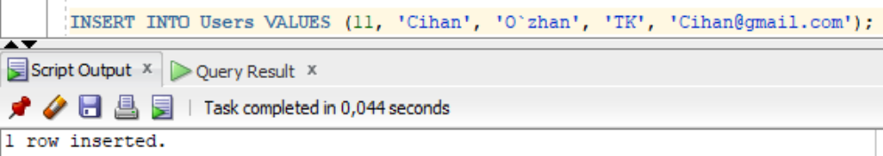

Endi Customer jadvalini tekshiramiz: yangilanish parallel sodir bo`ldi.

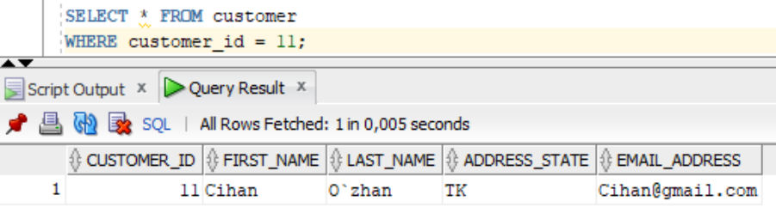

Drop Synonym:

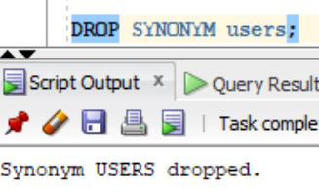

# VIEW

Kompleks View yaratish:

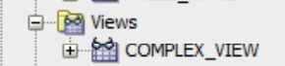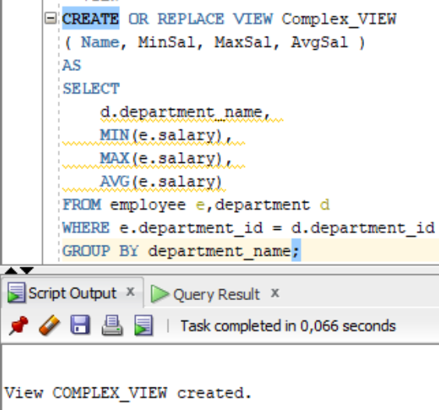

Viewni tekshiramiz:

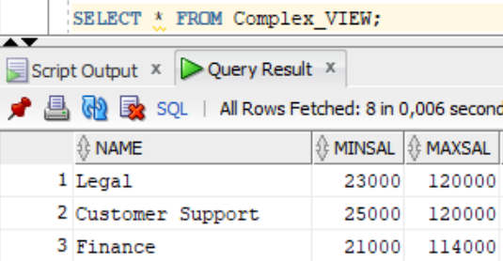

Viewnni o`chirish:

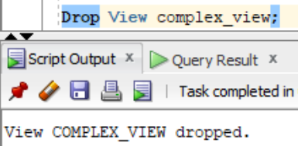

# Sequence

Create Sequence:

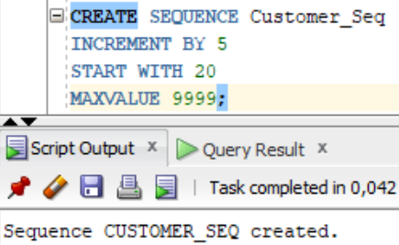

Customer jadvaliga ma’lumot kiritamiz:

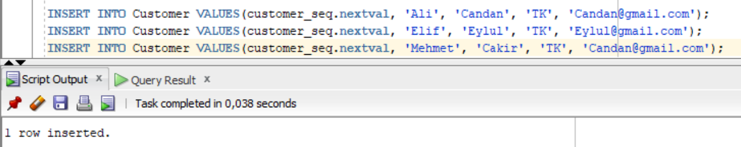

Customer jadvalini tekshiramiz:

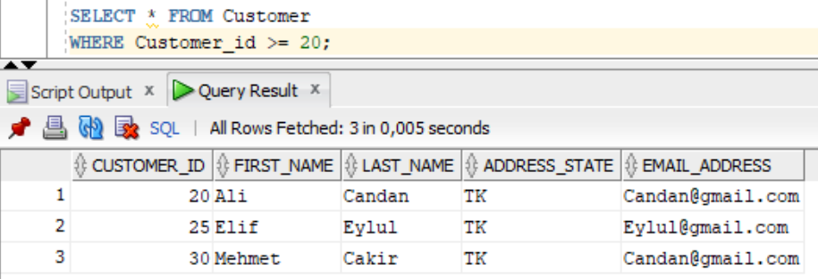

Sequence ning oxirgi qiymatini aniqlash:

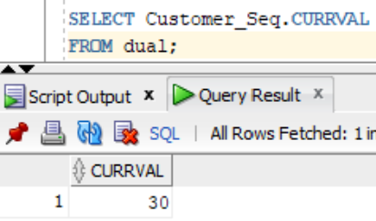

Userning barcha sequence larini ko`rish:

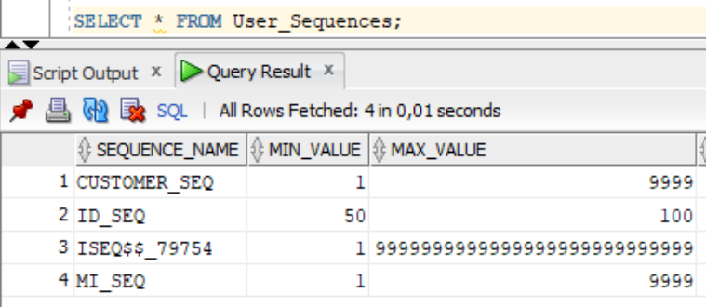

Hamma sequence larni ko`rish:

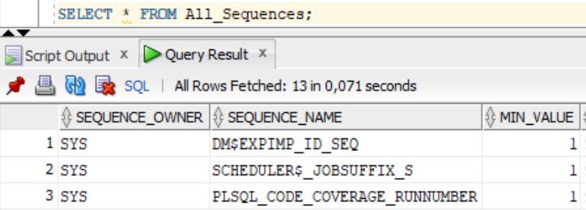

Drop Sequence:

